Job Profile comprising Job Description and Person Specification
Job Description

Job Title:  Oral Health Liaison Officer (Interim) | Grade:  Scale 2
Section:  Public Health | Directorate:  Adult Social Care and Public Health
Responsible to following manager:  Public Health Lead | Responsible for following staff:  N/A
Post Number/s: | Last review date:  May 2026

Working for the Richmond & Wandsworth Better Service Partnership

This role is employed under the Richmond & Wandsworth Better Service Partnership. The overall purpose of Richmond & Wandsworth is to provide the highest quality of service at the lowest attainable cost.

Staff are expected to deliver high quality and responsive services wherever they are based, as well as having the ability to adapt to sometimes differing processes and expectations.

Richmond & Wandsworth Better Service Partnership aims to be at the forefront of innovation in local government and the organisation will invest in the development of its staff and ensure the opportunities for progression that only a large organisation can provide.

Job Purpose
Provide professional support and assistance to the supervised toothbrushing portfolio across Richmond and Wandsworth, undertaking project activities and sharing good practice to ensure the smooth running of the service.

Specific Duties and Responsibilities

- Providing high quality professional support as required, including:
- General administration duties to support the supervised toothbrushing programme (STP) within the Public Health Team
- Supporting the promotion of STP and engagement with identified settings including distribution of promotion materials, hosting of events and parents and attendance of headteachers forums, inclusion into early year settings or school newsletters
- Coordinating programme logistics and the distribution and delivery of toothbrush packs, resources and equipment for all the supervised toothbrush programmes
- Updating & maintaining the local supervised toothbrushing programme dashboard and other associated data requests

- Ensure effective communication verbal/written communication with stakeholders & staff on all matters relating to the supervised toothbrushing programme at all times, incorporating tact, empathy, consideration, courtesy and confidentiality. This will include verbal, written and electronic media.
- Support the Community Dental Service (CDS) provider with recruitment of settings into the STP
- Act as the first point of contact, responding to the wider healthcare community, external organisations including early years settings, community settings and the public regarding enquiries and matters arising from the running of the supervised toothbrushing programme
- Ensure acceptable standards of data protection are maintained in accordance with the Data Protection Act and comply with all Council policies and procedures
- Provide support for a range of administrative tracking systems, including monitoring the supervised toothbrushing programme as directed, and ensure follow up and relevant action is taken as necessary.
- Meet regularly with the Supervised Toothbrushing team and actively participate in service and team development where appropriate
- To maintain own level of competency and attending relevant update courses

Generic Duties and Responsibilities
- To contribute to the continuous improvement of the services of Richmond & Wandsworth Better Service Partnerships.

- To comply with relevant Codes of Practice, including the Code of Conduct and policies concerning data protection, handling complaints and health and safety.

- To adhere to security controls and requirements as mandated by Richmond and Wandsworth procedures and local risk assessments to maintain confidentiality, integrity, availability and legal compliance of information and systems

- To promote equality, diversity, and inclusion, maintaining an awareness of the equality and diversity protocol/policy and working to create and maintain a safe, supportive and welcoming environment where all people are treated with dignity and their identity and culture are valued and respected.

- To understand both Councils’ duties and responsibilities for safeguarding children, young people and adults as they apply to the roles within the Councils.

- The profile is not intended to be an exhaustive list of the duties the post holder will carry out. Other reasonable duties commensurate with the level of the post, including supporting emergency and priority situations, will form part of the role.

Team structure

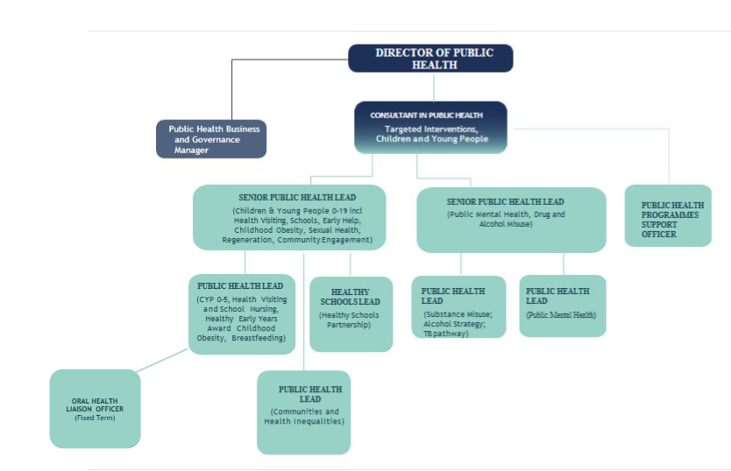

Person Specification

Job Title:  Oral Health Liaison Officer | Grade:  Scale 2
Section:  Public Health | Directorate:  Adult Social Care and Public Health
Responsible to:  Public Health Lead | Responsible for:  N/A
Post Number/s: | Last Review Date:  May 2026

Our Values
THINK BIGGER
EMBRACE DIFFERENCE
CONNECT BETTER
LEAD BY EXAMPLE
PUT PEOPLE FIRST

Our Values are embedded across Richmond & Wandsworth Better Service Partnership and throughout all roles and responsibilities at all levels of the organisation. Please familiarise yourself with our values as they are an integral part of our recruitment and selection process.

Person Specification Requirements |  |  |  | Assessed by  A/I/T/C  (see below for explanation)
 | Knowledge | Essential | Desirable | Assessed
 | Clear and effective communication skills both oral and verbal | X |  | A/I
 | Excellent IT skills with a working knowledge of Microsoft Office packages particularly Word, Access, Excel, and PowerPoint. Knowledge and understanding of spreadsheets | X |  | A/I
 | Awareness of Data Protection Act and confidentiality issues | X |  | A/I
 | Knowledge of basic project management principles | X |  | A/I
 | Knowledge of public health programmes in early years settings/school settings, |  | X | A/I
 | Understanding of safeguarding children and young people’s guidance and principles | X |  | A/I
 | Experience | Essential | Desirable | Assessed
 | Experience of working in a professional environment | X |  | A/I
 | Relevant experience of working as an admin and clerical officer or equivalent | X |  | A/I
 | Working with early years settings or primary schools |  | X | A/I
 | Skills
 | Excellent interpersonal skills and communication skills with the ability to communicate effectively with a variety of people | X |  | A/I
 | Excellent administration skills, including typing, and a confident telephone manner | X |  | A/I
 | Enthusiastic, motivated, and organised with a proactive and flexible approach | X |  | A/I
 | Ability to prioritise work to meet required deadlines. | X |  | A/I
 | Ability to work on own initiative and as part of a team to produce required end results. | X |  | A/I
 | Ability to maintain confidentiality | X |  | A/I
 | Demonstrate ability to pay good attention to detail, reliably check and record data, identify anomalies and be able to self-check completed work. | X |  | A/I
 | Show willingness to develop themselves by taking advantage of any appropriate training and development opportunities. | X |  | A/I
 | Ability to travel to locations to meet the requirements of the service (e.g. across Richmond and Wandsworth) | X |  | A/I
 | Qualifications
 | Minimum GCSEs (or equivalent qualifications) in Maths and English at grade C or above. | X |  | A/I
 | NVQ Level 3 in Business Admin or equivalent level of experience. | X |  | A/I

A – Application form / CV
I – Interview
T – Test
C - Certificate

