Job Profile comprising Job Description and Person Specification
Job Description

Job Title:  Executive Assistant | Grade:  PO1
Section:  Support and Member Services | Directorate:  Chief Executives Group
Responsible to following manager:  Head of Chief Executive’s Office | Responsible for:  N/A
Post Number/s:  HN009 | Last review date:  July 2025

Working for the Richmond & Wandsworth Better Service Partnership

We’re Richmond & Wandsworth Better Service Partnership, the shared public service team for Richmond and Wandsworth Councils. Like any local authority, our role is to deliver the agenda of our elected members on behalf of the people who live and work in our part of the world. We deliver key services to our communities including social care, public health, children’s services, housing and regeneration and environmental and community services.

Our joint workforce creates efficiency and resilience by bringing more creativity to the way we work, more objectivity and adaptability too, helping us deliver better services for all our residents.

We’re here to help our communities thrive in a changing world, and to be there for the people who need us most we believe we need to keep adapting. That’s why, at Richmond & Wandsworth Better Service Partnership, you’ll be at the forefront of innovation in local government, and we’ll invest in you and offer you opportunities to grow in a way only our unique organisation can.

Job Purpose
To provide comprehensive executive support to the Executive Director of Growth and Place. Including, diary and inbox management, meeting coordination, project and meeting support, coordination of briefings, and establishment of robust governance systems for directorate management and reporting.
This is a brand-new directorate, created to bring fresh thinking to how we plan, grow, and invest in our places. We’re building something from the ground up – meaning we are looking for someone who is energetic, can connect the dots, and thrives in fast-paced environments.

Specific Duties and Responsibilities

- Provide full executive support to the Executive Director, including managing correspondence, resident complaints, drafting letters, and handling confidential information. Additionally, completing other administrative tasks in supporting the Growth and Place Executive Director.
- Proactively manage and prioritise the Executive Director’s diary, ensuring appropriate briefing papers are prepared sufficiently in advance. Act as gatekeeper to optimise time and minimise unnecessary travel.
- Organise and support meetings (internal/external), including drafting agendas, papers, minutes, and action tracking; ensure timely follow-up.
- To show initiative, anticipate pressure points and potential problems and takes appropriate action. Prioritise requests as necessary and balance competing demands, ensuring that these are dealt with promptly and appropriately.
- Establish and maintain governance structures for Growth & Place, including Directorate Management Team (DMT) meetings, managing cadence and approvals. Develop and track forward plans, action logs, and reporting mechanisms.
- Ensure strong governance and controls for reports to Departmental Board and Member meetings, managing cadence and approvals.
- Coordinate updates for Cabinet Member briefings and maintain rolling agendas for 1:1 meetings.
- Support wider projects and directorate set-up activities, liaising across the Council to ensure delivery.
- Develop good working relationships and collaborative arrangements with internal and external stakeholders. Act as an effective communication link between the Growth and Place Executive Director and Council Leader’s, Cabinet Members, Committee Chairs and Directors; establishing effective relationships with other directorate support officers across the council.
- To maintain effective filing and data storage, including emails and retrieval systems utilising databases and spreadsheets
- To facilitate cover arrangements as appropriate for other Executive Assistants.
- To ensure that the services for both councils are dealt with on an equitable basis to deliver the standards required for each.

Generic Duties and Responsibilities

- To contribute to the continuous improvement of the services of the Boroughs of Wandsworth and Richmond.

- To comply with relevant Codes of Practice, including the Code of Conduct and policies concerning data protection and health and safety.

- To adhere to security controls and requirements as mandated by the SSA’s policies, procedures and local risk assessments to maintain confidentiality, integrity, availability and legal compliance of information and systems.

- To promote equality, diversity, and inclusion, maintaining an awareness of the equality and diversity protocol/policy and working to create and maintain a safe, supportive and welcoming environment where all people are treated with dignity and their identity and culture are valued and respected.

- To understand both Councils’ duties and responsibilities for safeguarding children, young people and adults as they apply to the role within the council.

- The Shared Staffing Arrangement will keep its structures under continual review and as a result the post holder should expect to carry out any other reasonable duties within the overall function, commensurate with the level of the post.
Additional Information
Whilst flexible and agile working is available, the nature of this role supporting a senior member of the Executive team, inevitably requires a high level of in-office visibility. Candidates should expect a need for a minimum of three days in the office. There may be evening and weekend working as required.

You may at times be asked to travel between two sites as required by the needs of the service.

Team structure
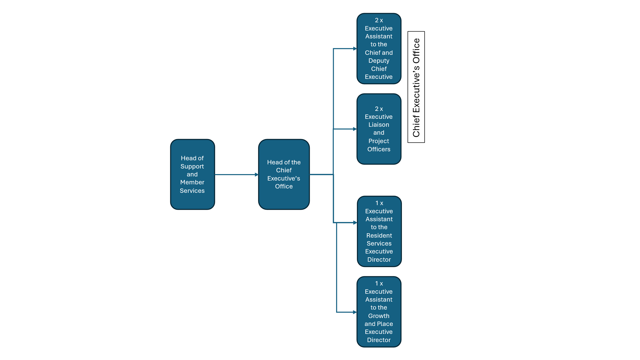

Person Specification

Job Title:  Executive Assistant | Grade:  PO1
Section:  Support and Member Services | Directorate:  Chief Executive’s Group
Responsible to:  Head of the Chief Executive’s Office | Responsible for:  N/A
Post Number/s  HN009 | Last Review Date:  July 2025

Our Values
THINK BIGGER
EMBRACE DIFFERENCE
CONNECT BETTER
LEAD BY EXAMPLE
PUT PEOPLE FIRST

Our Values are embedded across Richmond & Wandsworth Better Service Partnership and throughout all roles and responsibilities at all levels of the organisation. Please familiarise yourself with our values as they are an integral part of our recruitment and selection process.

Person Specification Requirements |  |  |  | Assessed by  A/I/T/C  (see below for explanation)
 | Knowledge | Essential | Desirable | Assessed
 | A good understanding of how local government works and the key issues / challenges facing local government. | E |  | A, I & T
 | Experience | Essential | Desirable | Assessed
 | Recent experience of working in an administrative/support role following and developing office procedures and managing paper and electronic records; experience of complex diary management. | E |  | A
 | Evidence of working in changing circumstances. | E |  | A & I
 | Experience of operating in a political environment, recognising and handling in an appropriate manner, confidential or sensitive information and distinguishing between political and non-political activities. |  | D | A & I
 | Strong focus on customer care, displaying tact, diplomacy and resilience when dealing with difficult situations and always projecting a confident and professional image. | E |  | A & I
 | Experience of supporting the development of administrative processes and business support systems to achieve best value for money. | E |  | A & I
 | Skills | Essential | Desirable | Assessed
 | Ability to use IT applications effectively to create high quality documents, presentations, spreadsheets, in an accurate and timely fashion and to showcase the appropriate corporate standards, using creativity and demonstrating great attention to detail. |  | D | A, I & T
 | Ability to research information (textual, financial and statistical) from a variety of sources and to present it in a consistent, concise and understandable way, both orally and in writing. |  | D | A & I
 | Ability to draft responses using principles of Plain English to complaints, letters, enquiries and requests without having to be instructed on every occasion, using common sense and initiative, thinking ahead (“horizon scan”) and anticipating needs and potential problems from the signals given. | E |  | A, I & T
 | Ability to work both independently and flexibly with limited supervision and to engage well with others. | E |  | A & I
 | Ability to work as an effective team member, using initiative and adapting to changing priorities and deadlines in a calm, well-organised and methodical manner. | E |  | A & I
 | Ability to recognise and handle in an appropriate manner, confidential or sensitive information. | E |  | A & I
 | Experience of supervising staff. |  | D | A
 | Qualifications | Essential | Desirable | Assessed
 | Educated to the degree level |  | D

A – Application form / CV
I – Interview
T – Test
C - Certificate

