Job Profile comprising Job Description and Person Specification
Job Description

Job Title: Gallery, Front of House Officer, Arts and Orleans House Gallery | Grade: SO1
Section: Arts | Directorate: Environment and Community Services
Responsible to following manager:  Front of House Manager | Responsible for following staff:  None  Supervision for volunteers and sessional staff
Post Number/s: | Last review date:

Working for the Richmond/Wandsworth Shared Staffing Arrangement

This role is employed under the Shared Staffing Arrangement between Richmond and Wandsworth Councils. The overall purpose of the Shared Staffing Arrangement is to provide the highest quality of service at the lowest attainable cost.

Staff are expected to deliver high quality and responsive services wherever they are based, as well as having the ability to adapt to sometimes differing processes and expectations.

The Shared Staffing Arrangement aims to be at the forefront of innovation in local government and the organisation will invest in the development of its staff and ensure the opportunities for progression that only a large organisation can provide.

Job Purpose

The Environment and Community Services Directorate is divided into four divisions and this role, is part of the Arts service which sits in the Culture division alongside Parks and sports.
The post holder will work closely with staff from across the council, within the arts service, partners, members of the public and members of outside organisations.

The Front of House Officers for Arts and Orleans House Gallery (OHG) are responsible for day to day operations for the Arts service, including Orleans House Gallery (Grade 1); for maintaining public access to the site; the day to day operations and associated systems and processes.

The service has been reviewed, and a restructure is underway. These are new posts within the redesigned structure.
This comes after the completion of a HLF project to restore renovate and rebuild OHG. The building re opened to the public in March 2018.
The service the capital assets and wider council structure are likely to continue to see substantial ongoing changes, alongside the fast-moving cultural context of the UK and Europe.

The role requires experienced staff members who have previously undertaken front of house roles, worked within public buildings, and have experience of working within agreed operating procedures, and customer care and public liaison with visitors.

The council is committed to providing a high quality publicly accessible creative and cultural programme across the borough. A service which whilst suitable for the location will offer exciting new ways to deliver creative practice and some surprises.

Specific Duties and Responsibilities

The FOH posts equate to 2.5FTE, working to this single generic job description.
We currently envisage that this include 1 FTE and 3x 0.5 FTE – or a maximum of 4 individuals.
It will include some evening and weekend working, shared across all the FOH positions.
The post holders will report to the Front of House Manager but will also be part of project teams that may be led by other staff. The post holders will work closely with our volunteer force and contribute to their training.

The Front of House officer on duty is responsible for enabling safe public access to the Arts Programme, gallery exhibitions, workshops and events. On occasion they will also manage other venues or operational sites where we provide creative services.
The post holders will be expected to act as Duty Manager and nominated key holder, taking responsibility for managing public safety, opening and closing of the site, be the main point of contact for the whole site, and managing any emergency issues if required.

- Whilst on duty to act as ‘duty manager’, with lead responsibility for public facing operations, safety of the site, staff and public. To ensure security measures maintaining the safekeeping of artworks on display.

- To maintain day to day safe, secure operations that also allow for the delivery of focussed high quality and innovative creative engagement activities.

- To ensure that the front desk, Stables Gallery and other key points are staffed, and all personnel maintain safe communication and follow policy best practice on personal safety issues.

- To be responsible for the presentation of the Orleans House site and building, and to assist with functions and hires as necessary, including setting up and clearing.

- To ensure the delivery of excellent customer care, including care from the Volunteers on front of house duties. Assisting the training of volunteers and maintaining customer standards.

- Dissemination of operational information to relevant personnel, regarding the daily arts programme; exhibitions, building/site, room hire and events.

- To manage the effective distribution of public facing Arts Service publicity and information on site. Manage postings on social media and mailouts. Maintain update and develop information databases as required.

- To liaise with the Front of House Manager in maintaining operational and administrative support: for example - ensuring the operation of equipment; monitoring and ordering key supplies (e.g. stationery); ensuring the site is kept clean and tidy; report building maintenance issues and faults/raise works orders, loading social media posts and information, updating mailing lists or other data resources, running the schedule of operational tests (water, alarms etc).

- To manage budgets and assist with our financial targets. Processing the till and PDQ machine, and other relevant pay points at the end of each day and making the day’s takings secure.

- To work flexibly across the directorate and provide support and cover to other staff as required.

Generic Duties and Responsibilities

- To contribute to the continuous improvement of the services of the Boroughs of Wandsworth and Richmond.

- To comply with relevant Codes of Practice, including the Code of Conduct and policies concerning data protection and health and safety.

- To adhere to security controls and requirements as mandated by the SSA’s policies, procedures and local risk assessments to maintain confidentiality, integrity, availability and legal compliance of information and systems

- To promote equality, diversity, and inclusion, maintaining an awareness of the equality and diversity protocol/policy and working to create and maintain a safe, supportive and welcoming environment where all people are treated with dignity and their identity and culture are valued and respected.

- To understand both Councils’ duties and responsibilities for safeguarding children, young people and adults as they apply to the role within the council.

- The Shared Staffing Arrangement will keep its structures under continual review and as a result the post holder should expect to carry out any other reasonable duties within the overall function, commensurate with the level of the post.
Additional Information: The post includes working regular weekends and evenings on a rota system. The venue is open 6 days a week, and programmes run over 7 days, weekends and evenings. Multiple sites and programmes will run at the same time. Both the establishment staff and other support staff and volunteers work across flexible hours.
FOH staff will require up to date first aid (at work) qualification. This training could be supplied after appointment to the post.
Team structure:

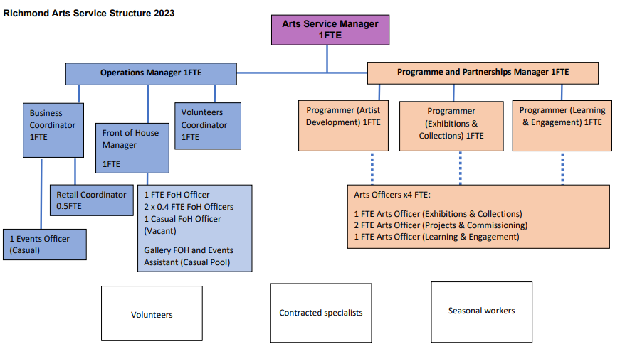
Person Specification

Job Title: Front of House Officer, Arts and Orleans House Gallery | Grade: Scale 5
Section: ECS Culture | Directorate: Environment and Community Services
Responsible to: Front of House Manager | Responsible for:  None
Post Number/s: | Last Review Date: April 2019

Our Values and Behaviours

The values and behaviours we seek from our staff draw on the high standards of the two boroughs, and we prize these qualities:

Being open. This means we share our views openly, honestly and in a thoughtful way. We encourage new ideas and ways of doing things. We appreciate and listen to feedback from each other.

Being supportive. This means we drive the success of the organisation by making sure that our colleagues are successful. We encourage others and take account of the challenges they face. We help each other to do our jobs.

Being positive. Being positive and helpful means, we keep our goals in mind and look for ways to achieve them. We listen constructively and help others see opportunities and the way forward. We have a ‘can do’ attitude and are continuously looking for ways to help each other improve.

Person Specification Requirements | Assessed by  A  & I/ T/ C (see below for explanation)
Knowledge
Knowledge of current best practice in operational venue management, with public access. | A
Knowledge of operational systems that enable the smooth delivery of services. Including business systems. | A
Knowledge of best practice when working with volunteers | A / I
Knowledge of good practice relating to manual handling and the handling of historic or art objects | A
Experience
Experience of working in a public facing role, and interactions with ‘customers. | A / I
Experience of managing security issues in relation to assets and people | A / I
Experience of working in compliance with systems and processes, including those related to public safety. | I
Managing and leading teams in a fast-moving dynamic environment. (Staff or project teams, including volunteers, of 2 plus individuals). | A / I
Budget reporting and management. | A / T
First aid at work qualification (Could be secured post appointment) | A/T
Skills
Ability to communicate clearly and effectively, both orally and in writing, with a wide range of individuals and customers. | A / I / T
Ability to set up, use and communicate to others, the basic equipment we use (including IT). | A/T
Ability to set up rooms, including moving equipment and the application of safe manual handling. | A
Ability to work independently and as an effective team member using own initiative. | I
Ability to adapt to changing priorities, contexts and deadlines. | A / I / T
ICT skills - an ability to maintain records and database systems. | I / T
Ability to use and post on social media and relevant social media platforms, for example web, twitter, Instagram, Facebook
Qualifications
First Aid at work qualification (could be secured post appointment) | A

A – Application form / CV
I – Interview
T – Test
C - Certificate

