Job Description and Person Specification

Job Title:  Building Safety Levy Officer | Grade:  SO2-PO1
Section:  Spatial Planning | Directorate:  Growth and Place
Responsible to following manager:  Information and Planning Obligations Team Manager | Responsible for following staff:  N/A
Post Number/s:  POS002143 | Last review date:  April 2026

Working for the Richmond & Wandsworth Better Service Partnership

Working for the Richmond/ Wandsworth Shared Staffing Arrangement

We’re Richmond & Wandsworth Better Service Partnership, the shared public service team for Richmond and Wandsworth Councils. Like any local authority, our role is to deliver the agenda of our elected members on behalf of the people who live and work in our part of the world. We deliver key services to our communities including social care, public health, children’s services, housing and regeneration and environmental and community services.

Our joint workforce creates efficiency and resilience by bringing more creativity to the way we work, more objectivity and adaptability too, helping us deliver better services for all our residents.

We’re here to help our communities thrive in a changing world, and to be there for the people who need us most we believe we need to keep adapting. That’s why, at Richmond & Wandsworth Better Service Partnership, you’ll be at the forefront of innovation in local government, and we’ll invest in you and offer you opportunities to grow in a way only our unique organisation can.

Job Purpose

This is a new industry position where the Building Safety Levy (BSL) Officer will support the administration of Building Safety Levy processes, including determining levy chargeability and liability, issuing levy determination notices, arranging spot checks, receiving payments and issuing payment certificates, dealing with requests for reviews from developers and Quarterly Management Information & revenue transfer to MHCLG. The role involves collaboration with internal teams (e.g. Finance, Planning, Building Control) and external stakeholders (e.g. the Building Safety Regulator, Registered Building Control Approvers, developers), ensuring clear communication in line with Local Authority procedures.

This role contributes to timely and accurate BSL collection in accordance with relevant regulations and financial protocols.

The role also requires you to support the CIL and S106 Officers in helping to deliver high quality, robust and transparent decision making within tight time frames on the administration of the Community Infrastructure Levy. This is to ensure that the Spatial Planning Service is recognised as delivering an excellent planning service for its customers.

Specific Duties and Responsibilities

- Support the Local Authority’s readiness for the Building Safety Levy go-live, monitoring progress against implementation milestones and escalate risks or delays to relevant stakeholders.

- Liaise with IT providers to ensure system updates are delivered and tested ahead of launch; support internal upskilling and provide feedback to improve usability. Assist in setting up reporting mechanisms and financial processes to enable accurate fund transfers and performance tracking.

- Contribute to internal governance arrangements by helping define roles, responsibilities, and process linkages across departments in readiness for implementation.

- Administer the end-to-end levy process, including determining chargeability and liability, issuing determination notices, managing payments and issuing payment certificates in accordance with relevant regulations.

- Manage levy cases from initial submission through to completion, including processing developer information, maintaining accurate records, and ensuring timely decision-making in line with statutory and corporate timescales.

- Undertake validation and spot checks of levy information, including assessment of exemptions, measurement of floorspace, and review of supporting evidence to ensure compliance with regulations and internal standards.

- Support the financial administration of the levy, including reconciliation of payments, preparation of quarterly monitoring information, and timely transfer of revenue to MHCLG in line with financial protocols.

- Act as a key point of contact for levy-related queries, providing clear and professional advice to developers, registered building control approvers, and internal teams.

- Work collaboratively with Planning, Finance, Building Control and other services to ensure coordinated and efficient levy administration and consistent application of processes.

- Maintain accurate and up-to-date records across relevant IT systems, ensuring data integrity, security and effective use of digital tools to support levy and CIL administration.

- Contribute to the development, implementation and continuous improvement of levy processes, systems and procedures, including supporting service readiness and ongoing operational efficiency.

- Maintain up-to-date knowledge of BSL, CIL and related planning legislation, ensuring changes are understood, applied consistently, and communicated to colleagues where appropriate.

- Support the achievement of service performance targets by ensuring work is delivered accurately, efficiently and within required deadlines, contributing to a high-quality planning service.

- Provide support to CIL functions, including assisting with calculation, administration, monitoring of development triggers, issuing statutory Notices and responding to related enquiries.

CRITERIA FOR PROGRESSION TO PO1 (as for SO2 plus the following)

- Takes a lead role in set up and implementation of BSL workflows and processes to ensure system readiness to meet Government requirements. Ensures continuous improvement and refinement of processes for the administration of the BSL, in accordance with the legislative framework and Government guidance.

- Works independently to administer complex BSL and CIL casework with minimal input from the Information and Planning Obligations Team Manager or Principal CIL and S106 Officer, proactively identifying issues and implementing resolutions.

- Leads and implements self-contained projects or components of larger projects in order to deliver organisational objectives as well as enabling agreed changes in planning practice and processes to take place.

- Coaches and facilitates the acquisition of skills and knowledge in others to that they are better equipped to be self-reliant in dealing with technical issues particularly focusing on complex, high profile and politically sensitive casework matters.

- When necessary, the postholder will be responsible for the direct supervision of at least one member of staff undertaking project-based work.

Generic Duties and Responsibilities

- To contribute to the continuous improvement of the services of Richmond & Wandsworth Better Service Partnerships.

- To comply with relevant Codes of Practice, including the Code of Conduct and policies concerning data protection, handling complaints and health and safety.

- To adhere to security controls and requirements as mandated by Richmond and Wandsworth procedures and local risk assessments to maintain confidentiality, integrity, availability and legal compliance of information and systems

- To promote equality, diversity, and inclusion, maintaining an awareness of the equality and diversity protocol/policy and working to create and maintain a safe, supportive and welcoming environment where all people are treated with dignity and their identity and culture are valued and respected.

- To understand both Councils’ duties and responsibilities for safeguarding children, young people and adults as they apply to the roles within the Councils.

- The profile is not intended to be an exhaustive list of the duties the post holder will carry out. Other reasonable duties commensurate with the level of the post, including supporting emergency and priority situations, will form part of the role.

Additional Information
Assists as required with management of budgets, including ensuring that all necessary processes and procedures are carried out in a timely and effective manner.
To disseminate knowledge and best practice amongst team and take responsibility for reviewing and checking calculations as required to do so.

Team structure

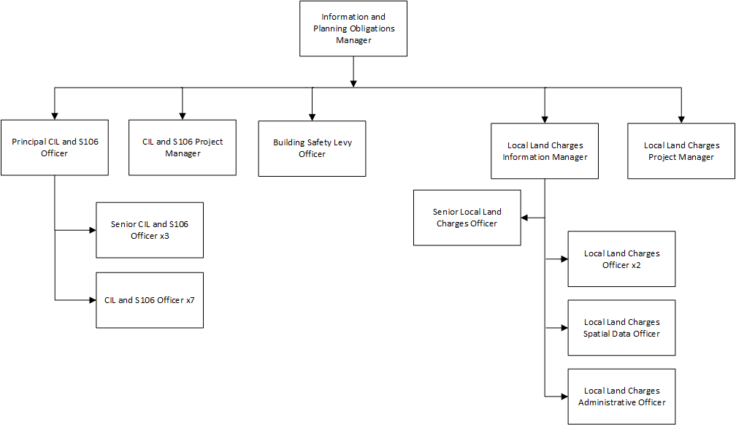

Person Specification

Job Title:  Building Safety Levy Officer | Grade:  SO2-PO1
Section:  Spatial Planning | Directorate:  Growth and Place
Responsible to following manager:  Information and Planning Obligations Team Manager | Responsible for following staff:  N/A
Post Number/s:  POS002143 | Last review date:  April 2026

Our Values
THINK BIGGER
EMBRACE DIFFERENCE
CONNECT BETTER
LEAD BY EXAMPLE
PUT PEOPLE FIRST

Our Values are embedded across Richmond & Wandsworth Better Service Partnership and throughout all roles and responsibilities at all levels of the organisation. Please familiarise yourself with our values as they are an integral part of our recruitment and selection process.

Person Specification Requirements |  |  | Assessed by  A/I/T/C  (see below for explanation)
Knowledge | Essential | Desirable | Assessed
An understanding of the Building Safety Levy Act and associated guidance | X |  | I/T
Knowledge of planning or building control procedures and regulatory frameworks |  | X
Knowledge of Community Infrastructure Levy with an up to date knowledge of the CIL Regulations and its application to development. |  | X | I
Advanced knowledge of Excel and Access and ability to use a wide range of computer software to collate, query, analyse, interpret and present data. | X |  | I/T
An understanding of planning and/or building control IT systems. | X |  | I
Familiarity with financial processes such as invoicing, payment tracking, and  reconciliation |  | X
Experience | Essential | Desirable | Assessed
Experience in administrative roles (preferably within a local authority or public  sector setting) | X
Experience in working in the administration and calculation of CIL. |  | X | I
Experience in working on detailed case work applying knowledge of legislation in a high-pressure environment | X |  | I
Skills | Essential | Desirable | Assessed
Proven information management and numeracy skills and ability to produce and collate accurate information and data reports | X |  | I
Ability to lead on designated projects with minimum supervision. |  | X | A
Ability to communicate and liaise effectively, both verbally and in writing, with a range of colleagues and customers. |  | X | A
Have a methodical approach to work with high levels of accuracy and ability to pay meticulous attention to detail. | X |  | A
A professional approach, with ability to interpret complex Regulations and make reasoned and consistent judgements. | X |  | I
A self-starter with the ability to get to grips with work quickly and independently. | X |  | A
Ability to work effectively to meet challenging deadlines and manage competing and changing priorities. | X |  | A
Ability to use initiative and identify innovative solutions to everyday challenges, continually striving to improve service delivery. |  | X | A
Qualifications | Essential | Desirable | Assessed
Membership or working towards membership of an appropriate professional body. |  | X | A

A – Application form / CV
I – Interview
T – Test
C - Certificate

