Job Profile comprising Job Description and Person

Specification Job Description

Job Title:  Stores Assistant | Grade:  SSA Scale 6  £32,841 - £38,637
Section:  Stores | Directorate:  Resident Services
Responsible to following manager:  Stores Supervisor | Responsible for following staff:  Not applicable
Post Number/s:  TS600 | Last review date: April 2026

Working for the Richmond/Wandsworth Shared Staffing Arrangement

This role is employed under the Shared Staffing Arrangement between Richmond and Wandsworth Councils. The overall purpose of the Shared Staffing Arrangement is to provide the highest quality of service at the lowest attainable cost.

Staff are expected to deliver high quality and responsive services wherever they are based, as well as having the ability to adapt to sometimes differing processes and expectations.

The Shared Staffing Arrangement aims to be at the forefront of innovation in local government and the organisation will invest in the development of its staff and ensure the opportunities for progression that only a large organisation can provide.

Job Purpose:

Responsible for providing a prompt and efficient stores service including serving, loading and unloading vehicles, restocking and ensuring a clean and tidy working environment. You will also supply mainly highways and building materials to our operational staff and keep our stores IT systems up to date.

Specific Duties and Responsibilities:

- Issuing materials and items to operatives and other members of staff.

- Booking materials from our operative’s requisition sheets into our localised computer system.

- Contacting suppliers to obtain the best prices and availability of various building materials held within the stores area.

- Speak to various suppliers, order various building and highways materials. Assist with stores purchasing, Creating purchase orders daily.

- Receiving, inspect and process deliveries including materials, plant and specialist equipment from suppliers ensuring accuracy of quantities, specifications and quality.

- loading and unloading materials and goods receiving on arrival.

- You must hold or be willing to train for a counterbalance forklift truck and JCB loader licence.

- Maintaining stock levels, picking van stocks and carrying out stock checks on a regular basis.

- Organise and maintain a safe, efficient and accessible stores layout ensuring all outside areas are kept in a clean and orderly manner.

- Ensure stores, plant and other valuable equipment are always kept secure including stores materials, loading shovel, forklift trucks and other high valuable items located within our stores and depot areas.

- Participate in winter gritting duties when required.

- Plan their works in a suitable manner to maximise their productivity and performance. They should also have the ability to maintain records of completed works and accurately record any amendments.

Generic Duties and Responsibilities

- To contribute to the continuous improvement of the services of the Boroughs of Wandsworth and Richmond.

- To comply with relevant Codes of Practice, including the Code of Conduct and policies concerning data protection and health and safety.

- To adhere to security controls and requirements as mandated by the SSA’s policies, procedures and local risk assessments to maintain confidentiality, integrity, availability and legal compliance of information and systems.

- To promote equality, diversity, and inclusion, maintaining an awareness of the equality and diversity protocol/policy and working to create and maintain a safe, supportive and welcoming environment where all people are treated with dignity and their identity and culture are valued and respected.

- To understand both Councils’ duties and responsibilities for safeguarding children, young people and adults as they apply to the role within the council.

- The Shared Staffing Arrangement will keep its structures under continual review and as a result the post holder should expect to carry out any other reasonable duties within the overall function, commensurate with the level of the post.
Additional Information
- Undertaking the standby scheme for the winter service on a rota basis and some staff will be required to participate in the Emergency Out of Hours Standby Service (including depot emergency cover and any additional out of hours service that is required). Should be prepared to respond to the Councils major Emergency Plan when required. E.g. sand bagging, storm damage etc.

Current team structure

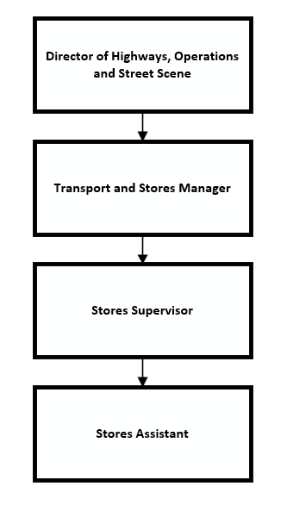

Person Specification
Job Title:  Stores Assistant | Grade:  SSA SCALE 6
Section:  Stores | Directorate:  Resident Services
Responsible to following manager:  Stores Supervisor | Responsible for following staff:  Not applicable
Post Number/s:  TS600 | Last review date:  April 2026

Our Values and Behaviours

The values and behaviours we seek from our staff draw on the high standards of the two boroughs, and we prize these qualities in particular:

Being open. This means we share our views openly, honestly and in a thoughtful way. We encourage new ideas and ways of doing things. We appreciate and listen to feedback from each other.

Being supportive. This means we drive the success of the organisation by making sure that our colleagues are successful. We encourage others and take account of the challenges they face. We help each other to do our jobs.

Being positive. Being positive and helpful means we keep our goals in mind and look for ways to achieve them. We listen constructively and help others see opportunities and the way forward. We have a ‘can do’ attitude and are continuously looking for ways to help each other improve.

Person Specification Requirements |  |  |  | Assessed by  A/I/T/C  (see below)
 | Knowledge | Essential | Desirable | Assessed
 | Working knowledge of highways and building materials |  | X | A/I
 | Good working knowledge of the requirements of the Health and Safety at Work Act | X |  | A/I
 | Experience | Essential | Desirable | Assessed
 | Experience operating mechanical plant machinery e.g. forklift truck and mechanical shovel |  | X | A/I
 | Experience working on different computer systems | X |  | A/I
 | Skills | Essential | Desirable | Assessed
 | Effective communication skills | X |  | A/I
 | Ability to work outside on all weathers | X |  | A/I
 | Ability to successfully manage large volumes of work | X |  | A/I
 | Ability to organise own work and to be able to work with minimum supervision. | X |  | A/I
 | Ability to successfully co-ordinate several different tasks at any one time, often with conflicting deadlines. | X |  | A/I
 | Ability to use own initiative | X |  | A/I
 | Ability to enter data and interrogate computer systems | X |  | A/I
 | An effective team player. | X |  | A/I
 | Must be able to demonstrate flexibility to meet demands of working hours. | X |  | A/I
 | Qualifications | Essential | Desirable | Assessed
 | Forklift operator trained |  | X | I/C

A – Application form
I – Interview
T – Test
C – Certificate

