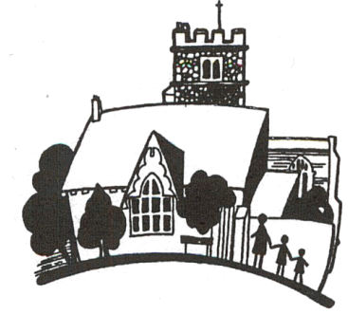

St. Mary’s CE Primary School
TEACHER OF ART AND DESIGN
Person Specification

Essential | Desirable
QUALIFICATIONS
- Graduate level qualification and Qualified Teacher Status (QTS)  - Evidence of ongoing professional development; attendance on courses, INSET  - At least three years successful teaching experience | - Degree or other in Art and Design and/or related field  - Evidence of action research, personal study etc.  - At least one/two years current/recent experience of leading/teaching Art across the Primary Phase
EXPERIENCE AND SKILLS
- Experience of teaching Art and Design in Early Years Foundation Stage, Key Stage One and Key Stage Two classes  - Written evidence of good/outstanding Art lesson observations  - Competence in the use of ICT/New Technologies to engage and promote pupil learning  - High expectations of students in terms of behaviour and achievement  - Ability to deploy a range of strategies for managing pupil behaviour  - Successful experience leading a broad, balanced and differentiated Art and Design curriculum  - Achievement in raising standards in Art and Design  - Excellent written and oral communication skills | - Experience of more than one Primary School setting
KNOWLEDGE AND UNDERSTANDING
- Extensive subject knowledge
- A thorough knowledge of the requirements of the Early Years Foundation Stage and National Curriculum
- A thorough understanding of how assessment of and assessment for learning drives school improvement
PERSONAL QUALITIES
- A clear vision and passion for Art and Design
- The highest expectation of self and others
- Highly creative, motivated and enthusiastic
- Ability to motivate and inspire pupils
- Ability to utilise time and to deploy resources effectively within an agreed budget
- Willingness to play a part in the wider life of the school
- To be able to promote the Christian ethos of the school
- Have a sense of humour, resilience and tenacity
APPROACH TO WORK
- Excellent organisational skills
- High professional standards
- Ability to work effectively as a member of a team
- A commitment to child-centred education
- A commitment to ensuring that all pupils have the opportunity to participate in a range of activities
- A commitment to developing the school’s role in the community as a source of learning, development and well being
- A commitment to working in partnership with parents, governors, the Local Authority, the Church – at local and Diocesan level, to provide the best education possible for our children

Your application form should be completed and free from error. Your supporting statement should be clear and concise and directly related to the person specification above and should be no more than three sides of A4 in length.

