Job Profile comprising Job Description and Person Specification
Job Description

Job Title:  Local Authority Research Practitioner (fixed term) | Grade: PO1
Section:  Public Health | Directorate:  Adult Health and Social Care and Public Health
Responsible to following manager:  Senior public health lead | Responsible for following staff:  N/A
Post Number/s:  POS001416 | Last review date: October 2025

Working for the Richmond & Wandsworth Better Service Partnership

We are Richmond & Wandsworth Better Service Partnership, the shared public service team for Richmond and Wandsworth Councils. Like any local authority, our role is to deliver the agenda of our elected members on behalf of the people who live and work in our part of the world. We deliver key services to our communities including social care, public health, children’s services, housing and regeneration and environmental and community services.

Our joint workforce creates efficiency and resilience by bringing more creativity to the way we work, more objectivity and adaptability too, helping us deliver better services for all our residents.

We are here to help our communities thrive in a changing world, and to be there for the people who need us most we believe we need to keep adapting. That is why, at Richmond & Wandsworth Better Service Partnership, you’ll be at the forefront of innovation in local government, and we will invest in you and offer you opportunities to grow in a way only our unique organisation can.

Job Purpose

The purpose of the role is to support research development at hyperlocal Richmond and Wandsworth Councils and PLACE South West London in keeping with the ambition to support local authority developing a research function to build research capacity and embed a research culture within the local authority to promote robust evaluation.

The Local Authority Research Practitioner will be instrumental in providing the capacity to engage with and develop research approaches. This will include through supporting the building of appropriate research governance and ethics frameworks within the council, strengthening relationships with local universities and establishing the best approach for engaging in future research opportunities, such as through funding awards and grants.

The role is a full time role and will cover Local Authority and South West London research strategy development.
The Local Authority Research Practitioner will support the Public Health division in research development, working with the Public Health Quality Assurance and Older People, PHQA lead and the Consultant in Public Health leading on Research development, for 3 days a week. The Local Authority Research Practitioner will also work directly with the Integrated Care System Director of Health Improvement for 2 days a week to help support the delivery of the SWL research strategy. This will include organising the SWL Research Support Network which supports communities, voluntary sector, evaluation ambassadors and peer researchers.

Specific Duties and Responsibilities

- Establish an internal Richmond and Wandsworth Public Health Research Development working group.
- Work with the Research Development Project Supervisor to create a Public Health Research Capacity and Capability Development Plan.
- Work with the Research Development Project Supervisor to establish a network of local academic and public health partners.
- Work with the Consultant of Public Health leading on workforce development to conduct a research and evaluation training needs analysis and support with the development of internal resources to standardise evaluation and research approaches.
- Work with the Research Development Project Supervisor and Consultant in Public Health leading on research development to develop and implement a suitable approach to research and evaluation governance and ethics reviews.
- Identify suitable research funding awards and establish a best approach to applying for these awards, considering the extent of collaboration with academic and local partners.
- Work to foster a research and evidence-based culture across the council.
- Work with the Winstanley York Road Community Capacity and Engagement Lead and Evaluation Lead to develop a Community Research Capacity Building Model.
- Work with South West London (SWL) Integrated Care System (ICS) Director of Health Improvement and Head of Health Improvement to Identify and support elements of the SWL research delivery plan.
- Support the SWL ICS with the design, organisation and communications for the SWL Research Support Network .
- Help bring different SWL parties together to write and deliver on research bids (i.e. local public health teams, local universities and, where needed, the NHS).
- Promote collaboration and joint working on knowledge mobilisation activities across the SWL system including voluntary organisations and communities.
- Align the research development work in Richmond and Wandsworth councils with work happening across South West London, to ensure a streamlined approach that builds on existing good practice.
- Actively promote, support and contribute to the activity of the Specialist Centre for Public Health.
- Contribute to the sharing of best practice across Local Authorities as part of a LARP network.
- Link with Public Health Engagement Leads (PHELs).
- Undertake regular reporting to the SCPH (Newcastle University and partners) to support the evaluation of the LARP roles and demonstrate impact on research capacity and capability in Local Authorities.

Generic Duties and Responsibilities

- To contribute to the continuous improvement of the services of Richmond & Wandsworth Better Service Partnerships.

- To undertake mandatory training

- To comply with relevant Codes of Practice, including the Code of Conduct and policies concerning data protection, handling complaints and health and safety.

- To adhere to security controls and requirements as mandated by Richmond and Wandsworth procedures and local risk assessments to maintain confidentiality, integrity, availability and legal compliance of information and systems

- To promote equality, diversity, and inclusion, maintaining an awareness of the equality and diversity protocol/policy and working to create and maintain a safe, supportive and welcoming environment where all people are treated with dignity and their identity and culture are valued and respected.

- To understand both Councils’ duties and responsibilities for safeguarding children, young people and adults as they apply to the roles within the Councils.

- The profile is not intended to be an exhaustive list of the duties the post holder will carry out. Other reasonable duties commensurate with the level of the post, including supporting emergency and priority situations, will form part of the role.
Additional Information
This role will involve two days per week working with the Director of Health Improvement and Head of Health Improvement within the South West London Integrated Care Board.

Team structure

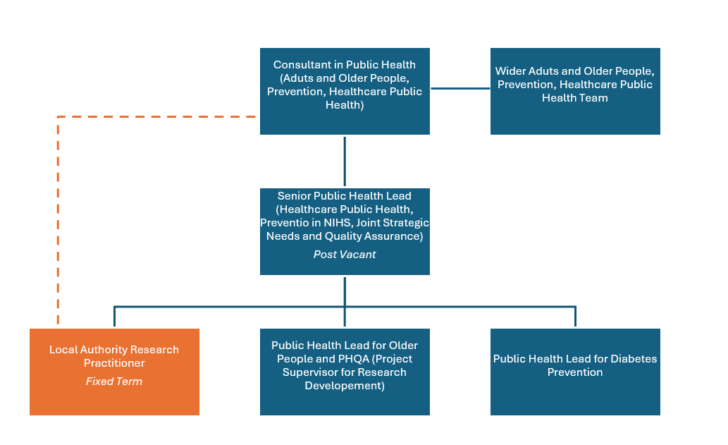

Person Specification

Job Title: Local Authority Research Practitioner (fixed term) | Grade: P01
Section: Public Health | Directorate: Adult Health and Social Care and Public Health
Responsible to: | Responsible for:
Post Number/s:  POS001416 | Last Review Date: October 2025

Our Values
THINK BIGGER
EMBRACE DIFFERENCE
CONNECT BETTER
LEAD BY EXAMPLE
PUT PEOPLE FIRST

Our Values are embedded across Richmond & Wandsworth Better Service Partnership and throughout all roles and responsibilities at all levels of the organisation. Please familiarise yourself with our values as they are an integral part of our recruitment and selection process.

Person Specification Requirements |  |  |  | Assessed by  A/I/T/C  (see below for explanation)
 | Knowledge | Essential | Desirable | Assessed
 | Understanding of Research Governance and Ethics Processes | X |  | A/I
 | Understanding of research funding award processes | X |  | A/I
 | Knowledge of Public Health and Health Inequalities | x |  | A/I
 | Experience | Essential | Desirable | Assessed
 | Experience of delivering health related research | X |  | A/I
 | Experience in managing or undertaking research projects | X |  | A/I
 | Experience of Public Health related research or working in a Public Health setting | x |  | A/I
 | Experience of working in an academic or research setting or organisation |  | X | A/I
 | Experience of Public Patient Involvement (PPI) |  | X | A/I
 | Skills | Essential | Desirable | Assessed
 | Strong verbal and written communication skills | X |  | A/I
 | Strong negotiation and influencing skills, in particular around stakeholder engagement. | X |  | A/I
 | Strong project management skills | X |  | A/I
 | Ability to work to tight deadlines and manage multiple priorities | X |  | A/I
 | Ability to work autonomously and act with initiative | X |  | A/I
 | Qualifications | Essential | Desirable | Assessed
 | Undergraduate degree or equivalent experience in a health-related setting | X |  | A
 | Project Management Qualification |  | X | A

A – Application form / CV
I – Interview
T – Test
C - Certificate

