Job Profile comprising Job Description and Person Specification

Job Description

Job Title:  Information Support Officer | Grade:  SO1-SO2
Section:  Business Resources | Directorate:  Adult Social Care and Public Health
Responsible to:  Business Support Manager (Information) / Senior Information Support Officer | Responsible for the following staff:  N/A
Post Number/s:  RWABSI04 | Last review date:  October 2025

Working for the Richmond & Wandsworth Better Service Partnership

We’re Richmond & Wandsworth Better Service Partnership, the shared public service team for Richmond and Wandsworth Councils. Like any local authority, our role is to deliver the agenda of our elected members on behalf of the people who live and work in our part of the world. We deliver key services to our communities including social care, public health, children’s services, housing and regeneration and environmental and community services.

Our joint workforce creates efficiency and resilience by bringing more creativity to the way we work, more objectivity and adaptability too, helping us deliver better services for all our residents.

We’re here to help our communities thrive in a changing world, and to be there for the people who need us most we believe we need to keep adapting. That’s why, at Richmond & Wandsworth Better Service Partnership, you’ll be at the forefront of innovation in local government, and we’ll invest in you and offer you opportunities to grow in a way only our unique organisation can.

Job Purpose:

- Is the first point of contact for all public enquiries and received under the Freedom of Information Act 2000 (FOI) and Data Protection Act 2018 (DPA) and UK General Data Protection Regulation (UK GDPR) and associated legislation. Manages the process for logging, distributing, monitoring and co-ordinating responses.

- Provides advice and guidance on the above areas to ASC&PH senior management and co-ordinates MP and Council Member enquiries ensuring the department complies with its statutory responsibilities.

Specific Duties and Responsibilities:

- Is the Directorate contact point for Freedom of Information requests (FOIs)and Subject Access Requests (SARs) received under the Freedom of Information Act 2000 and Data Protection Act 2018 and UK GDPR and for enquiries from Members of Parliament and Council Members maintaining professional communications with internal/external customers.

- Leads on co-ordinating and processing FOIs/SARs/ME requests ensuring that they are managed and responded to in a professional manner and in line with all statutory requirements.

- To provide specialised support, advice, clarification and assistance to ASC&PH senior managers and staff in relation to FOI/SARs/ME requests.

- To process subject access requests under UK GDPR/ DPA 2018 including locating and collating, scanning all data relating to data subjects and combine, create and prepare electronic pdf versions on SharePoint.

- To provide professional advice in relation to legislation relevant to handling of SARs and FOIs.

- To provide a high-level redaction support service for the Council with particular focus on work arising from the Children’s Social Care and Adult Social Care teams ensuring that all documents to be redacted are done so in accordance with best practice and guidance.

- To implement effective and accurate monitoring systems. Manage, monitor and facilitate all enquiries and responses relating to FOIs/SARs/MEs working with colleagues and managers to ensure compliance with council standards and statutory requirements.

- Establish effective working relationships with Council Members, Senior Managers and colleagues in ASCPH/CS and requesters and communicate with them as appropriate, for FOIs/SARs/MEs, keeping them informed of progress and liaising with them to ensure responses are sent within deadline.

- To manage the production of statistical data and compile regular and ad-hoc reports on FOIs/SARs/MEs for senior managers on monitoring and compliance with council standards and statutory requirements.

- To establish and maintain a professional dialogue with Subject Access Request applicants to ensure that any areas of concern or sensitivity are identified in a timely manner and handled appropriately.

- To escalate particularly complex issues to the Business Support Manager (Information) in a timely manner, for discussion with senior colleagues in the relevant areas.

- To support the Business Support Manager (Information) in providing advice and training, designing and implementing processes, flow charts, procedures to ensure that ASCPH/CS complies with the relevant legislation.

- To ensure that the services for both Councils are dealt with on an equitable basis to deliver the standards required for each, as agreed annually by the Executives of both Councils.

- To advise and support managers on relevant matters affecting the service.

- To contribute as required to performance review and improvement measures on an ongoing basis, helping to ensure that a customer focus is embedded within the function and innovative and creative solutions are evaluated to secure the highest quality and value for money function.

- To contribute as required to change programmes within the service.

- To support ways of working that ensure residents and stakeholders are actively engaged in the future of the function and are able to influence decision making.

- To work as required in ways that develop good working relations and collaborative arrangements with internal and external stakeholders.

- To act as Deputy Business Support Manager (Information) as required.

Career Progression procedure for linked grades

The post holder needs to have successfully completed any probation to be considered for progression. Progression between scales is not a time measured right but based on competence, skills, performance and ability for the post holder to demonstrate that they are meeting the advanced competencies in the job description. The post holder will need to demonstrate that they have met the advanced competencies over a 6-month (minimum) period.

The postholder will build their own portfolio to present to the Business Support Manager and Head of Business Support. Different types of evidence for the portfolio are acceptable including supervision notes, appraisals, audits, complex projects which can be anonymised and used as evidence. Business Support Manager will then make a recommendation for progression, and progression requests will be moderated and agreed as appropriate.

Progression criteria for SO2

In addition to the Specific Duties and Responsibilities:

- The Information Support Officer should evidence knowledge of UK GDPR/DPA 2018/FOI 2000 by responding to ASC/PH and CS staff, managers and requesters on all issues relating to the above legislation.

- The Information Support Officer should be able to confidently lead/chair meetings/discussions with the Business Support Manager, Head of Service and ASCPH/CS staff and provide and receive feedback.

- The Information Support Officer should when disclosing information on difficult enquiries and information requests prepare empathetic responses to requesters that take into account advice and guidance from managers and reviewers.

- The Information Support Officer should be able to represent the Senior Information Support Officer and Business Support Manager (Information) in a professional manner at meetings and working groups.

- The Information Support Officer should take ownership for making improvements and implementing processes/practice within the team to ensure effective and innovative ways of working.

Generic Duties and Responsibilities

- To contribute to the continuous improvement of the services of Richmond & Wandsworth Better Service Partnerships.

- To comply with relevant Codes of Practice, including the Code of Conduct and policies concerning data protection, handling complaints and health and safety.

- To adhere to security controls and requirements as mandated by Richmond and Wandsworth procedures and local risk assessments to maintain confidentiality, integrity, availability and legal compliance of information and systems

- To promote equality, diversity, and inclusion, maintaining an awareness of the equality and diversity protocol/policy and working to create and maintain a safe, supportive and welcoming environment where all people are treated with dignity and their identity and culture are valued and respected.

- To understand both Councils’ duties and responsibilities for safeguarding children, young people and adults as they apply to the roles within the Councils.

- The profile is not intended to be an exhaustive list of the duties the post holder will carry out. Other reasonable duties commensurate with the level of the post, including supporting emergency and priority situations, will form part of the role.

Additional Information
Team structure

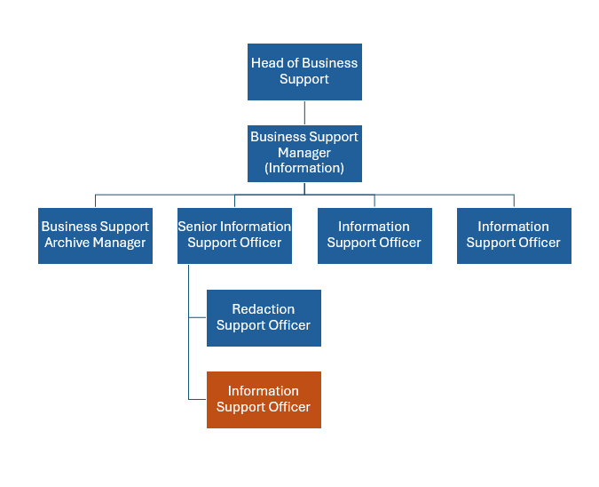

Person Specification
Job Title:  Information Support Officer | Grade:  SO1-SO2
Section:  Business Resources | Directorate:  Adult Social Care and Public Health
Responsible to:  Business Support Manager (Information) / Senior Information Support Officer | Responsible for:  N/A
Post Number/s:  RWA 1124? | Date:  October 2025

Our Values

THINK BIGGER
EMBRACE DIFFERENCE
CONNECT BETTER
LEAD BY EXAMPLE
PUT PEOPLE FIRST

Our Values are embedded across Richmond & Wandsworth Better Service Partnership and throughout all roles and responsibilities at all levels of the organisation. Please familiarise yourself with our values as they are an integral part of our recruitment and selection process.

Person Specification Requirements |  |  | Assessed by  A/I/T/C  (see below for explanation)
Knowledge | Essential | Desirable | Assessed
A working knowledge of:  Data Protection legislation and regulation;  Freedom of Information Act 2000, including exemptions; and  the Information Security standard ISO27001. | x  x | x | A/I

Knowledge cont | Essential | Desirable | Assessed
Knowledge of Subject Access Requests and Freedom of Information enquiries including exemptions. | x |  | A/I
Good level of knowledge in relation to the duties described in the job description to ensure effective decision making and to be able to provide authoritative advice to people inside and outside the Council. | x |  | A/I
Experience | Essential | Desirable | Assessed
Some experience of dealing with highly confidential and sensitive issues, including complex and contentious issues. | x |  | A/I
Experience of managing small group(s) of staff, with positive outcomes. |  | x | A/I
Experience in successfully implementing programmes or projects to deliver defined outcomes and priorities. | x |  | A/I
Some experience of appropriately allocating staff resources. |  | x | A/I
Skills | Essential | Desirable | Assessed
A good level of written and oral communication skills to provide clear and concise messages. | x |  | A/I
Intermediate level of IT skills to use standard IT packages and be able to support others in their day-to-day use and to set up spreadsheets/ databases for monitoring and reporting purposes. Ability to manage multiple and shared mailboxes. | x |  | A/I
Ability to use a client record system for locating records and use of case notes. | x |  | A/I

Skills continued | Essential | Desirable | Assessed
Ability to successfully organise and prioritise own workload, to work under pressure and meet deadlines. | x |  | A/I
Ability to advise officers and senior management on information support and related procedures and legislation to attain compliance. | x |  | A/I
Evidence of ability to use initiative, problem-solving, analytical and evaluation skills. | x |  | A/I
Qualifications | Essential | Desirable | Assessed
Educated to GCSE level with a minimum Grade C in English. | x |  | A/C
Evidence of further education/continuing professional development and also a willingness to undertake personal development and training relevant to the role. |  | x | A/C

A – Application form / CV
I – Interview
T – Test
C - Certificate

