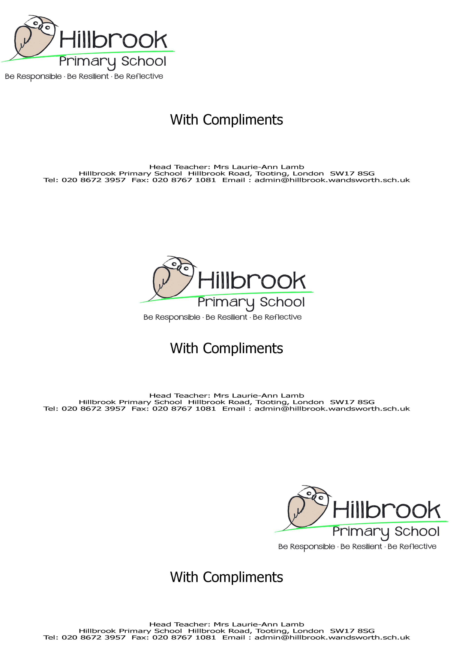

Job Description
Job Title | Administration Assistant
Relationships/Line Management
Responsible to:
- School Business Manager
Important relationships:
- Pupils and parents
- Other members of staff
- The Governing Body
- Outside Agencies
Main Purpose of Job
Under the direction of the School Business Manager, provide the necessary high quality admin support.
Organisation and Administration
- Be the first point of contact for all enquiries and visitors to the school, including dealing with telephone queries and personal callers. Ensure all visitors sign in and the security of the school is maintained at all times;
- Assist with pupils, including first aid and welfare. Looking after sick pupils, liaising with parents and staff
- Provide high level clerical and administrative support e.g. typing, word processing, photocopying, printing, display, collection and recording of money, making telephone calls etc.;
- Operate relevant equipment and ICT packages e.g. SIMS.net, Microsoft Office, Outlook;
- Assist in the organisation of school dinners, dinner registers & liaising with staff
- Manage distribution of milk to pupils;
- Assist with school diary, daily notices and information to parents;
- Sort and distribute incoming post, and dispatch outgoing post;
- Produce lists, information and data as required e.g. pupil’s data
- Process as directed all applications received for the entitlement of free school meals; update and maintain records of children entitled to a free meal.
- Assist in checking deliveries against delivery notes;
- Assist in organising and preparing for meetings, for example setting up rooms and arranging refreshments;
- Monitor and maintain adequate levels of Administrative supplies.
Standards and Quality Assurance
- Supporting and upholding the aims and the ethos of the school
- Working within agreed policies and practices, as drawn up by the School. Be aware of and comply with policies and procedures relating to child protection, health, safety and security, confidentiality and data protection, reporting all concerns to an appropriate person
- Appreciate and support the role of other professionals
- Attend relevant meetings as required. Participate in training and other learning activities and performance development as required
- To be fully aware of and understand the duties and responsibilities arising from the Children’s Act 2004 and Working Together in relation to child protection and safeguarding children and young people as this applies to the worker’s role within the organisation
- To also be fully aware of the principles of safeguarding as they apply to vulnerable adults in relation to the worker’s role
- To ensure that the safeguarding officer is made aware and kept fully informed of any concerns which the worker may have in relation to safeguarding and/or child protection.
- Carrying out all responsibilities and activities within an Equal Opportunities framework.
This job description is intended to be a broad outline of duties and is not intended to be exhaustive. The post-holder will be expected to take on other duties and responsibilities commensurate with the grade of the post as directed by the School Business Manager or Headteacher.
You are expected to treat all information acquired through your employment both formally and informally, in strict confidence. There are strict rules and protocols defining employees’ access to and use of the Council’s databases. Any breach of these rules and protocols will be regarded as subject to disciplinary investigation. There are internal procedures in place for employees to raise matters of concern regarding such issues as bad practice or mismanagement.
Signed:
Date:
Acknowledged by:
Date:

Person Specification

Post Title: Administration Assistant
 | Essential | Desirable
Qualifications
- GCSE qualification, Grade A-C (or equivalent) in English and Maths  - First aid qualification | ✓ | ✓
Experience
- Ability to relate well and communicate effectively to children and adults  - Proven IT experience  - Clerical/Administrative experience  - School Reception/Front of House experience  - SIMS | ✓  ✓  ✓  ✓ | ✓
Professional Knowledge, Skills and Abilities
- Maintain appropriate professional relationships and boundaries with pupils, parents and other outside agencies  - Ability to work constructively as part of a team, but also to be able to work on your own initiative.  - Ability to deliver quality customer service to all visitors in a calm, efficient and professional manner.  - Ability to relate and communicate well to children and to adults.  - Knowledge of situations involving pupils or staff that need to be referred to the Headteacher.  - Ability to react calmly in an emergency with health and safety of both pupils and staff their prime concern  - An understanding of the school’s equal opportunities policy and how it is implemented  - Ability to use relevant technology e.g. computer, photocopier effectively  - Excellent oral, numeracy, literacy and IT skills  - Ability to accurately input data and use a variety of software applications including Microsoft Office and Outlook  - Ability to prioritise and to manage their time effectively  - Be flexible and able to work using own initiative  - Ability to work under pressure and meet tight deadlines | ✓  ✓  ✓  ✓  ✓  ✓  ✓  ✓  ✓  ✓  ✓  ✓  ✓
Work Related Attributes, Qualities, Competencies
- Willingness to participate in development and training opportunities  - Be patient and understanding  - Deal with sensitive information in a confidential manner  - Show a commitment to equal opportunities and safeguarding  - Willingness to make a full and positive contribution to the office and the environment of the school.  - To be enthusiastic, energetic, conscientious and committed | ✓  ✓  ✓  ✓  ✓  ✓

