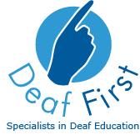
Further Education – Teacher of the Deaf

Person Specification

Essential

- Sign Language to a minimum of BSL level 2

- Ability to work independently

- To be able to provide basic skills support to students on Adult Literacy or Numeracy courses

- Have a good basic sound understand of Office packages

- Good communication skills

- Good interpersonal skills

- Commitment to equal opportunities

- Teacher of the Deaf Qualification

Desirable

- An understanding of issues relating to deaf students in Further and Higher Education

- Ability to use sign language to level 3 or the willingness to learn

- An understanding of vocational subjects offered by Colleges

- Qualified Teacher Status for Further Education Colleges

- Knowledge of how to implement EHCP’s

- Support applications for writing bids

- To be able to manage a budget for the department

