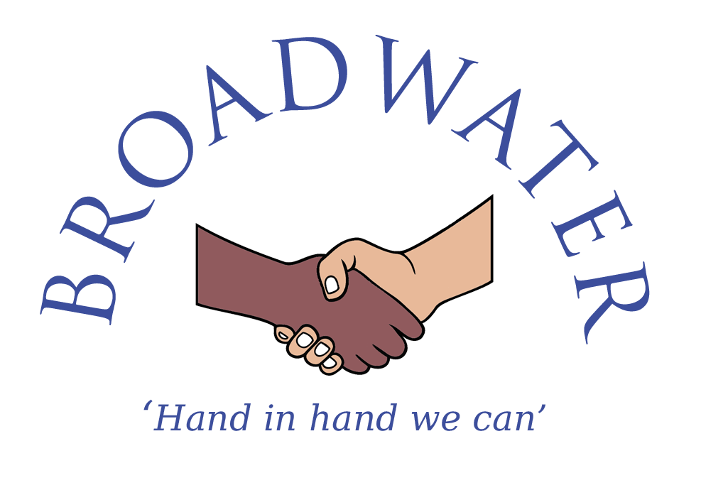
Temporary Part Time Key Stage Two French (Modern Foreign Languages) Teacher
PPA Cover – 0.4 (2 days)

Start Date: Immediate (will defer to Summer term for the right candidate)
Salary: Mainscale
Contract type: Teacher’s Pay and Conditions
Contract term: Temporary

Job Specification

Job Purpose
To take responsibility and provide effective teaching and learning of French for allocated pupils determined on an annual basis by the Headteacher and in accordance with the duties listed below.

Responsible to:
The Headteacher and the Governing Board.

Duties:
- As stated within the latest School Teachers’ Pay and Conditions document. The post holder will be expected to undertake duties in line with the professional standards for qualified teachers taking account of their current position on the pay spine.

- Strategic Direction and Development

To contribute to the discussion of the aims and policies of the organisation. To participate in the implementation of school policies, plans, targets and practices.

- Take responsibility for implementing school policies and practices;
- Plan and assess pupil’s learning in French using knowledge of school policies, schemes of work and National Curriculum requirements for Modern Foreign Languages;
- Maintain the positive ethos and core values of the school, both inside and outside the classroom;
- Contribute to constructive team-building amongst teaching and non-teaching staff, parents and governors;
- Have lead responsibility for Modern Foreign Languages and develop plans which identify clear targets and success criteria for its development and/or maintenance;
- Participate in meetings which relate to the school's management, curriculum, administration or organisation;
- Promote the school’s mission statement, ‘Hand in hand, we can.’

- Teaching and Learning

To secure and sustain effective teaching of a Modern Foreign Language (French) for individuals, groups and classes. Develop the quality of teaching, assess the standards of pupil’s achievements and set targets for improvement.

- Use school policy and National Curriculum requirements to set clear targets for improvement of pupils’ achievement and monitor pupil progress towards these targets;
- Ensure pupils acquire and consolidate knowledge, skills and understanding appropriate to Modern Foreign Languages (French);
- Make accurate assessments, independently, in line with the school’s assessment system, and performance standards associated with other relevant tests;
- Plan effectively to ensure that pupils have the opportunity to meet their potential, notwithstanding differences of race or gender, and taking account of the needs of pupils who are: underachieving, most able, disadvantaged, not yet fluent in English, making use of relevant information and specialist help where available;
- Plan effectively, where applicable, to meet the needs of pupils with Special Educational Needs and, in collaboration with teaching staff and the Head of Inclusion, make an appropriate contribution to the preparation, implementation, monitoring and review of Individual Support Plans;
- Take appropriate account of ethnic and cultural diversity to enrich the curriculum and raise achievement;
- Reflect on own teaching to improve effectiveness.

- Managing and Working with People

To lead, manage and work collaboratively with pupils and, as appropriate, with other adults and colleagues.

- Secure a high standard of pupil behaviour through establishing appropriate rules and high expectations of discipline which pupils respect, acting to pre-empt and deal with inappropriate behaviour in line with the school’s behaviour policy;
- Lead, organise and direct support staff effectively in the classroom, involving them, where appropriate, in the planning and management of pupils’ learning;
- Work as a member of a team, planning co-operatively, sharing information, ideas and expertise;
- Communicate and cooperate effectively with specialists from outside agencies;
- Liaise effectively with pupils, parents and carers through informative oral and written reports on pupils’ progress and achievements, discussing appropriate targets and encouraging them to support their children’s learning, behaviour and progress;
- Take responsibility for own professional development, setting objectives for improvements, and take action to keep up-to-date with research and developments in pedagogy and in the subjects taught;
- Participate in the performance management system for the appraisal of own performance, or that of other staff.

- Deployment of Staff and Resources

To develop, monitor and control resources within the teaching areas

- Organise and maintain a stimulating working environment appropriate for a range of activities;
- Teach pupils to take responsibility for resources and the environment;
- Ensure that resources are organised and readily available to promote a purposeful environment for teaching and learning to take place.

Additional Duties

- To be aware of and comply with policies and procedures relating to Child Protection and Safeguarding, Health and Safety, and report all concerns to the appropriate person.
- Undertake other general tasks that the Headteacher may reasonably ask.

