
Hotham Primary School
Charlwood Road
London
SW15 1PN

Join Our Team
Class Teachers required from September 2023

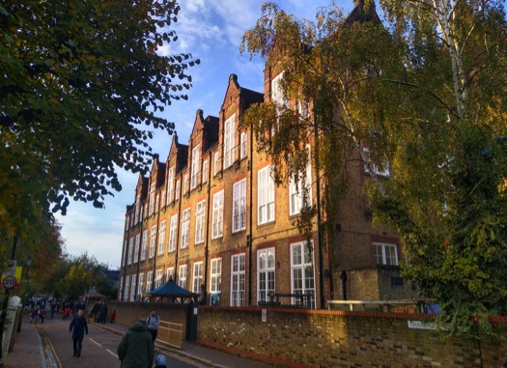
Welcome to Hotham

Thank you for your interest in the position of Class Teacher at Hotham Primary School.

Hotham is a confident and creative two-form entry community school in the heart of Putney. A key word to life at our school is ‘purpose’. We believe that children need to understand what they are learning, why they need to know it and to have the opportunity to apply their learning in meaningful ways. Purpose also extends to our decision making as a staff team. Everything we choose to do must have a positive impact on our children and help our school achieve its vision.

Our school is a successful school. Wellbeing is prioritised for all members of our school community. Children are given limitless opportunities to succeed and routinely achieve above national averages. Ofsted judged Hotham as ‘good’ under the new framework in a recent inspection which took place in autumn 2019. We value languages, with all pupils learning integrated French from nursery upwards.

We are looking for Class Teachers to join our committed and enthusiastic staff team. As a Hotham staff member, you can expect regular and relevant professional development, opportunities to work across phases, be creative and risk taking in your teaching and work closely with colleagues in planning and training. You will be an integral part of this wonderful school and supported by an experienced and supportive leadership team. As a school, we never sit still and we always expect the best for our children and families.

As a school, we can offer you:
- A commitment to wellbeing;
- Generous PPA time and technology that works;
- A unique curriculum which aims to reduce teacher workload;
- Opportunities to share your passion, both through our curriculum and a large range of clubs;
- An open-minded and forward-thinking ethos;
- Supportive parents and an amazing PTA;
- Dedicated colleagues and a culture of mutual support;
- Opportunities for professional development and career progression;
- A large, diverse and well-equipped school site.

We are looking for someone who shares our values and is ready to take the next step in their career. Hotham is a wonderful school, and we think carefully about each recruitment decision we make. If this post sparks your curiosity, I would encourage you to get in touch. Visits to the school at a mutually beneficial time can be arranged by contacting the school office. ECTs and more experienced candidates are welcome to apply.

Thank you for your interest in our school, and I look forward to meeting you soon.

Richard Byrne-Smith
Headteacher


Our Vision

Hotham is a diverse, dynamic and successful school, which prepares all children for life in London and the wider world.

We make the most of our location in one of the world’s greatest cities.

Our strong commitment to purposeful learning gives every child limitless opportunities and aspirations for the future.

Our school is bright, modern and well-equipped, with specialist facilities for sport and the arts, and we have green spaces for outdoor learning.

We welcome everyone through our doors, and together, our community raises children who are kind, confident, articulate and respectful.

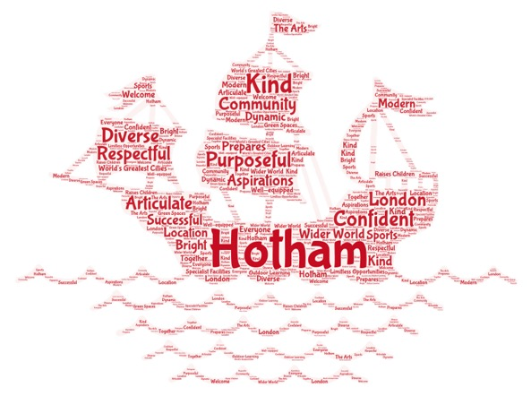

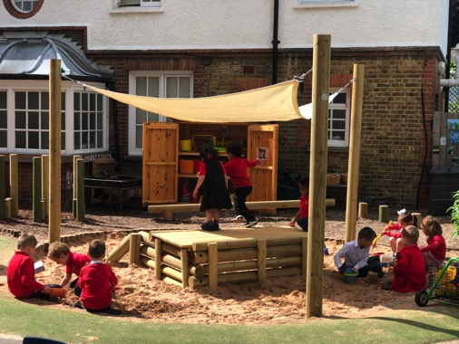

Our Values

Our three core values represent the overarching principles which guide our actions and behaviour as a school. They apply to all members of our school community: pupils, staff, parents and governors.

We respect ourselves, each other and our environment.
We take responsibility for our learning and our actions.
We show resolve in the face of every challenge.

Limitless opportunities for every child to aspire and succeed

Job Description
Class Teacher – Teachers’ Pay Scale

The appointment is subject to the current conditions of employment for Class Teachers contained in the School Teachers' Pay and Conditions Document, the 1998 School Standards and Framework Act, the required standards for Qualified Teacher Status and Class Teachers and other current legislation.

This job description may be amended at any time following discussion between the head teacher and member of staff, and will be reviewed annually.

Areas of Responsibility and Key Tasks

a) Planning, Teaching and Class Management
- Ensure that planning and teaching enables all children to achieve and make clear progression
- Identifying clear teaching objectives and specifying how they will be taught and assessed
- Setting tasks which challenge pupils and ensure high levels of interest
- Setting appropriate and demanding expectations
- Setting clear targets, building on prior attainment
- Identifying SEN or very able pupils;
- Provide clear structures for lessons maintaining pace, motivation and challenge;
- Make effective use of assessment and ensure coverage of programmes of study;
- Ensure effective teaching and best use of available time;
- Monitor and intervene to ensure sound learning and discipline
- Use a variety of teaching methods to:
- match approach to content, structure information, present a set of key ideas and use appropriate vocabulary;
- use effective questioning, listen carefully to pupils, give attention to errors and misconceptions;
- select appropriate learning resources and develop study skills through library, I.C.T. and other sources
- Ensure pupils acquire and consolidate knowledge, skills and understanding appropriate to the subject taught;
- Evaluate their own teaching critically to improve effectiveness;

Additional Standards for Nursery and Early Years:
- Take account of pupils' needs by providing structured learning opportunities which develop the areas of learning identified in national and local policies and particularly the foundations for literacy and numeracy;
- Encourage pupils to think and talk about their learning, develop self-control and independence, concentrate and persevere, and listen attentively;
- Use a variety of teaching strategies which involve planned adult intervention, first-hand experience and play and talk as a vehicle for learning;
- Manage parents and other adults in the classroom.

b) Monitoring, Assessment, Recording, Reporting
- Assess how well learning objectives have been achieved and use them to improve specific aspects of teaching;
- Mark and monitor pupils' work and set targets for progress;
- Assess and record pupils' progress systematically and keep records to check work is understood and completed, monitor strengths and weaknesses, inform planning and recognise the level at which the pupil is achieving;
- Prepare and present informative reports to parents.

c) Other Professional Requirements
- Have a working knowledge of teachers' professional duties, legal liabilities and professional standards
- Be reflective, adaptable and proactive
- Be willing to share and model very good or outstanding practice
- Operate at all times within the stated policies and practices of the school;
- Establish effective working relationships and set a good example through their presentation and personal and professional conduct;
- Endeavour to give every child the opportunity to reach their potential and meet high expectations;
- Contribute to the corporate life of the school through effective participation in meetings and management systems necessary to coordinate the management of the school;
- Take responsibility for their own professional development and duties in relation to school policies and practices;
- Liaise effectively with parents and governors.
- Take on any additional responsibilities which might from time to time be determined.
- Show a commitment towards school policies in Equal Opportunities and Child Protection, have a full understanding of these policies and embrace all aspects of school policy in relation to these areas.

Person Specification
 | Essential | Desirable
Qualifications
Educated to degree level
Qualified teacher status
Excellent literacy and numeracy skills
Satisfactory DBS and safeguarding checks
Experience
Proven ability as an excellent class teacher
Experience of working successfully as part of a team
Teaching experience across different age ranges
Professional Knowledge, Understanding and Skills
Has a working knowledge of teachers' professional standards, duties and legal responsibilities
Has a good understanding of the National Curriculum
Knows what constitutes quality and high standards in learning and teaching to raise standards and pupil outcomes
Able to plan lessons effectively, using pupils’ prior learning and areas for development as a starting point
Understands the principles of inclusion and is able to adapt classroom practice to include the needs of all learners
Able to use assessment information to provide feedback, plan next steps and improve outcomes for pupils
Understands the principle of Equality of Opportunity
Understands and shows a commitment towards safeguarding, child protection and wellbeing
Specific Skills and Abilities
Good ICT knowledge and skills and an ability to use technology to enhance the learning and teaching of all subjects
Able to communicate effectively (both orally and in writing) to a variety of audiences
Demonstrates a willingness to share good practice across the school (including running INSET, dependent on experience)
Has a good working knowledge of the French language
Personal Qualities
Understands the school aims and values, and has a genuine desire to promote these
High expectations of themselves and the children they teach
Good interpersonal skills, with the ability to enthuse and motivate children and adults
Able to establish and develop close relationships with parents, governors and the community
Has a flexible approach to work and is a proactive team member who shows respect for their colleagues
Able to manage own work load effectively
Shows an openness and willingness to constantly improve, building upon feedback and demonstrating the drive to be an outstanding practitioner
Visiting Hotham

We are hoping to be able to host visits for prospective candidates during the week beginning 22nd March.

The visit will be hosted by the headteacher and there will be the opportunity to ask questions informally. If you are interested in visiting, please email recruitment@hotham.wandsworth.sch.uk
How to Apply

For further information and to apply please download an application and details below or from the Wandsworth Council website, https://jobs.richmondandwandsworth.gov.uk/

Please return the completed application to the school either by email (preferred) to recruitment@hotham.wandsworth.sch.uk, or post

Closing date: Sunday 4 June 2023 (at midnight)
Interviews: Week beginning 5 June 2023


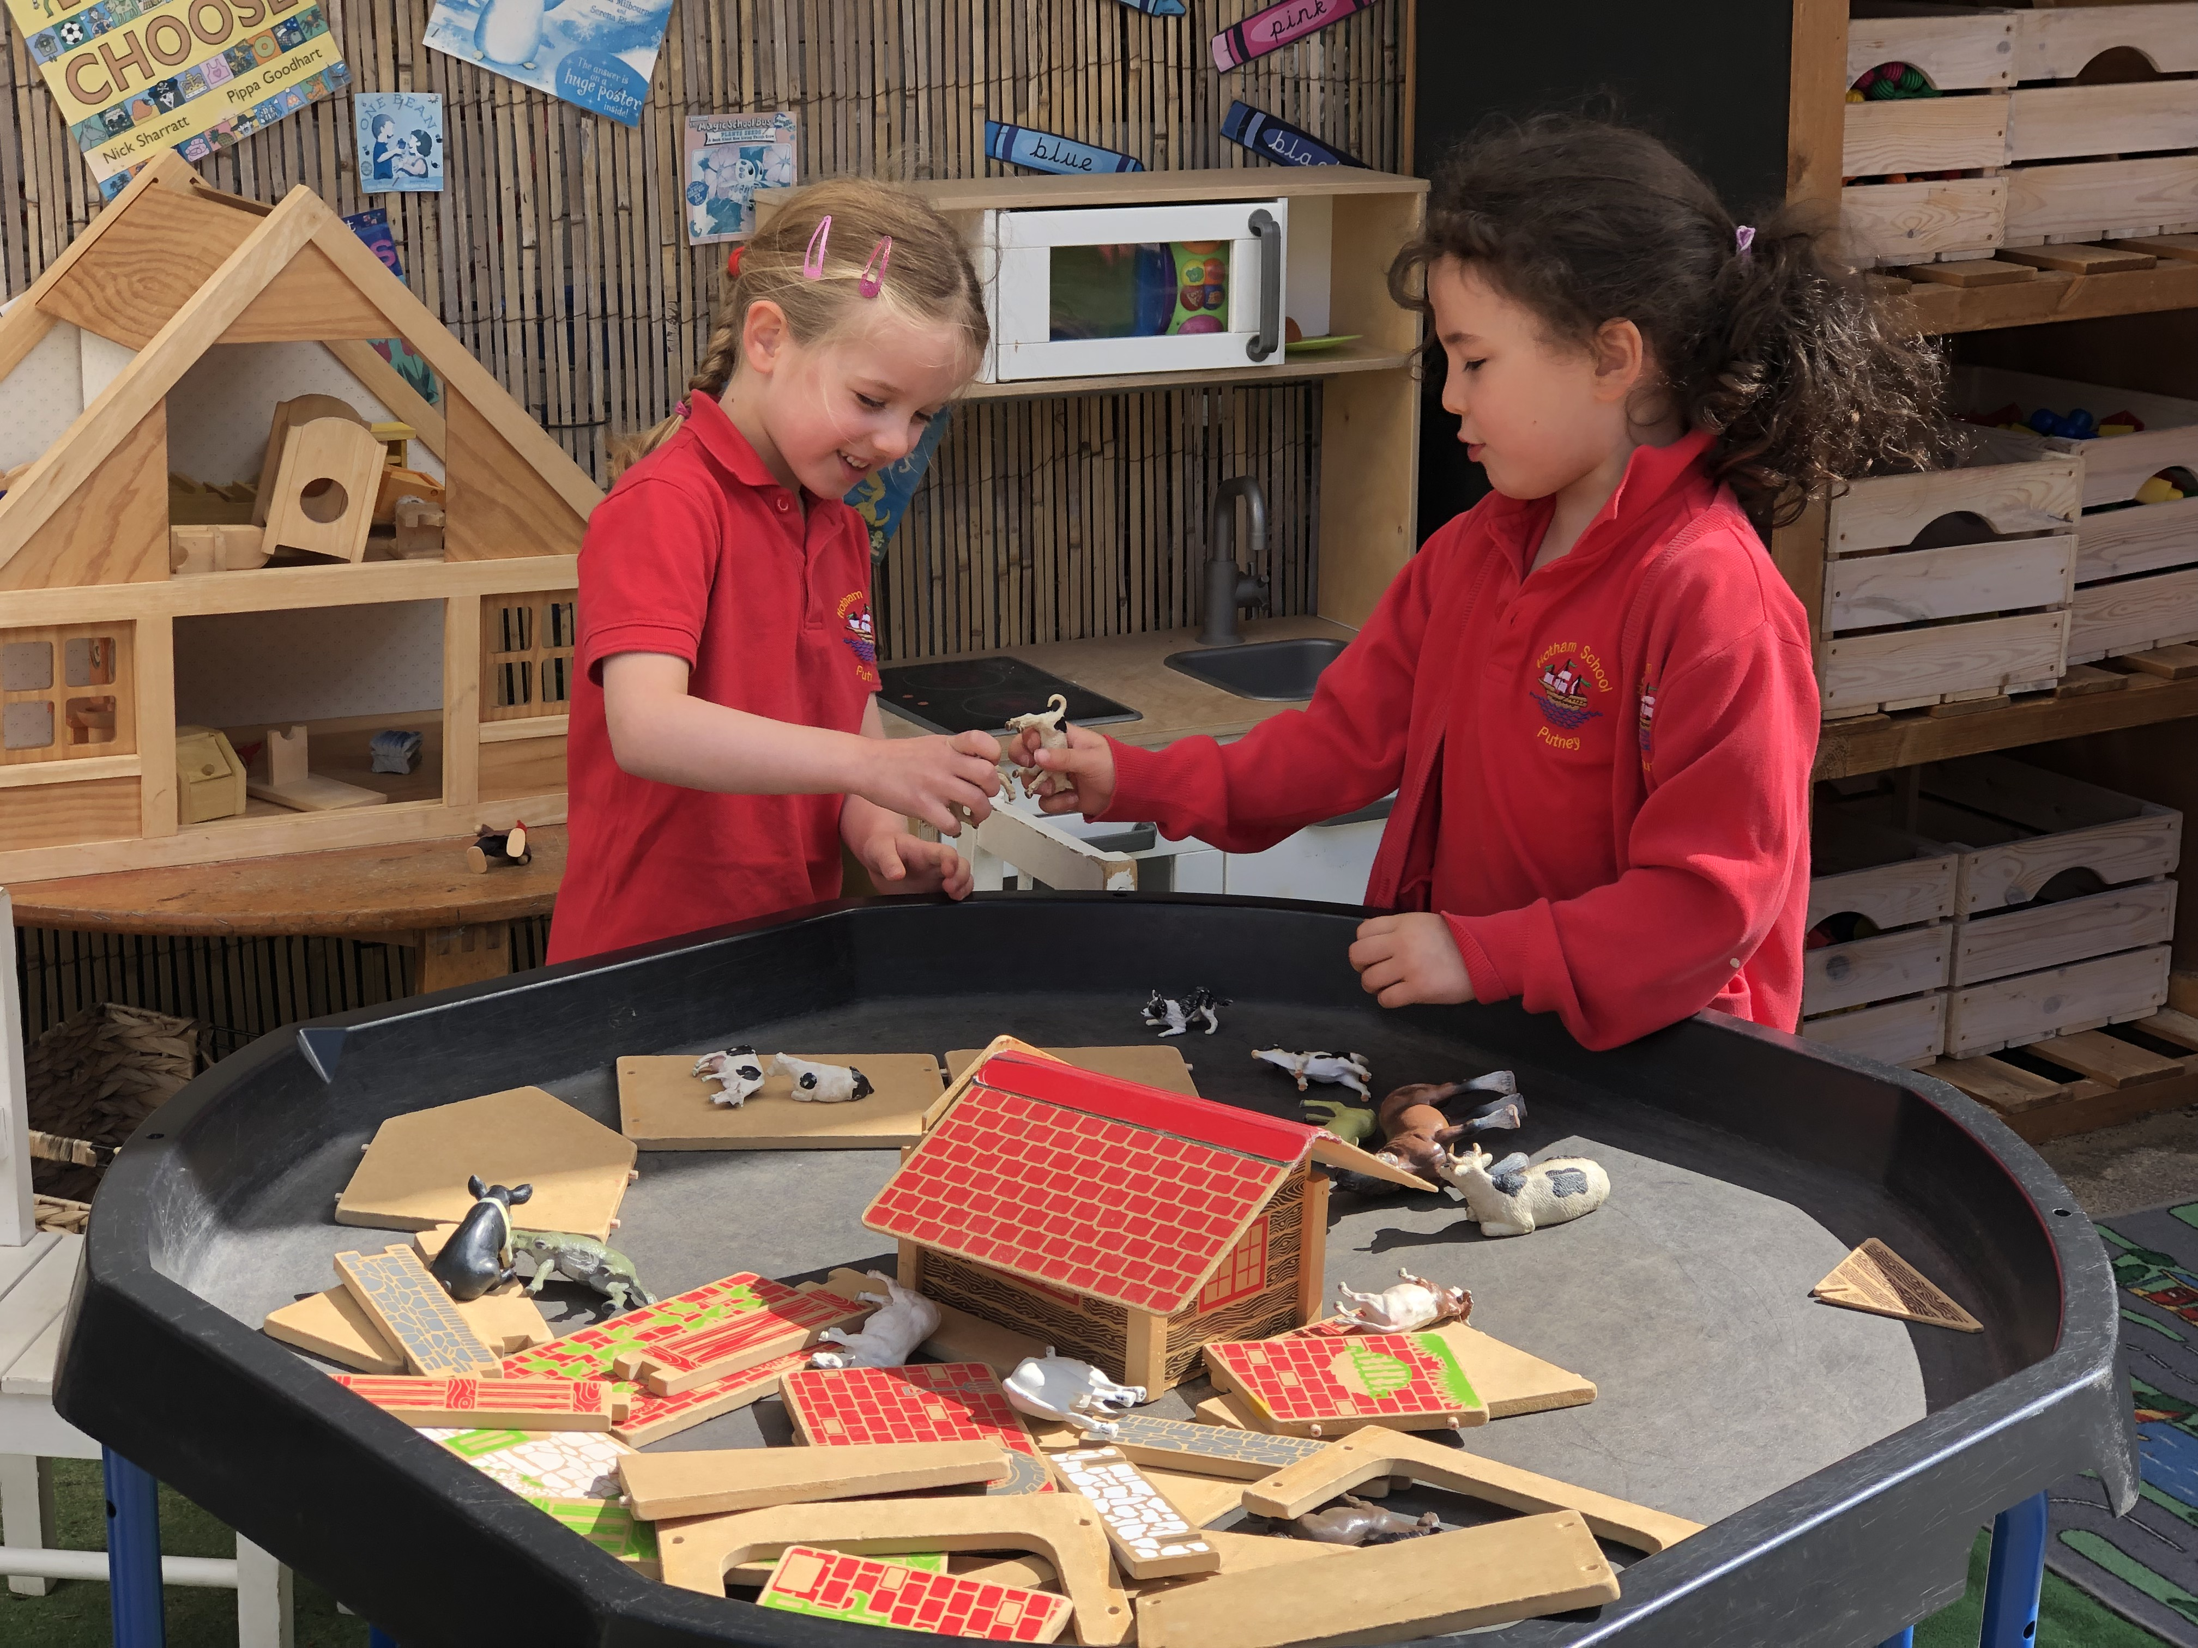
Commitment to Safeguarding

We are committed to safeguarding and promoting the welfare of children, young people and vulnerable adults and expect all staff and volunteers to share this commitment.

This post is subject to a satisfactory DBS check and references.
CVs are not accepted.

