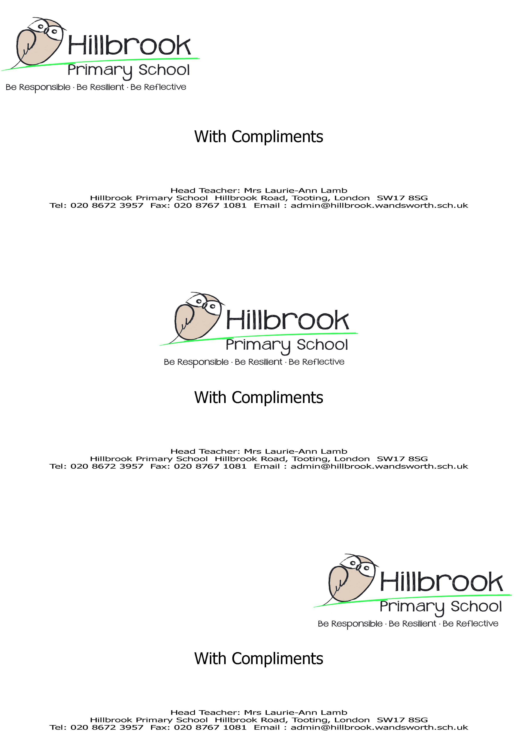

Job Description
Name
Job Title | SEN Admin Assistant
Relationships/Line Management
Responsible to:
- Assistant Head teacher/SENCO/Deputy Head - Inclusion
Responsible for:
- SEN admin / communication
Important relationships:
- Pupils and parents
- Other members of staff
- The Governing Board

Main Purpose of Job
To provide general admin duties specifically related to SEN department and routine clerical support.
Administration and Resources
- Provide routine clerical support e.g. photocopying, filing, emailing, complete routine forms
- Maintain manual and computerised records/ management information systems
- Undertake typing, word-processing and other IT based tasks
- Operate relevant equipment and ICT packages e.g. SIMS.net, Microsoft Office, Outlook including Outlook calendar.
- Produce lists, information and data as required.
- To liaise with external professionals through email and telephone calls.
Support for SENCO
- Undertake pupil record keeping as requested
- Gather and report information from and to parents or carers as directed
- Provide basic clerical and administrative support e.g. photocopying, typing, filing, collecting money etc.
- To greet and timetable visitors to the school, both professionals and parents
Support for the School
- Be aware of and comply with policies and procedures relating to child protection, health, safety and security, confidentiality and data protection, reporting all concerns to an appropriate person
- Contribute to the overall ethos, work and aims of the school
- Appreciate and support the role of other professionals
- Attend relevant meetings as required
- Participate in training and other learning activities and performance development as required
- To be fully aware of and understand the duties and responsibilities arising from the Children Act 2004 and Working Together in relation to child protection and safeguarding children and young people as this applies to the worker’s role within the organisation
- To be fully aware of the principles of safeguarding as they apply to vulnerable adults in relation to the worker’s role
- To ensure that the worker’s line manager is made aware and kept fully informed of any concerns which the worker may have in relation to safeguarding and/or child protection

Responsibilities
- Be aware of and comply with policies and procedures relating to child protection, health, safety and security, confidentiality and data protection, reporting all concerns to an appropriate person.
- Be aware of GDPR and confidentiality.
- Be aware of and support difference and ensure equal opportunities for all
- Contribute to the overall ethos, work and aims of the school
- Appreciate and support the role of other professionals
- Attend and participate in relevant meetings as required
- Participate in training and other learning activities and performance development as required
- To be fully aware of and understand the duties and responsibilities arising from the Children Act 2004 and Working Together in relation to child protection and safeguarding children and young people as this applies to the worker’s role within the organisation
- To also be fully aware of the principles of safeguarding as they apply to vulnerable adults in relation to the worker’s role
- To ensure that the worker’s line manager is made aware and kept fully informed of any concerns which the worker may have in relation to safeguarding and/or child protection

This job description allocates duties and responsibilities but does not direct the particular amount of time to be spent on carrying them out and no part of it may be so construed.
Signed:
Date:
Acknowledged by:
Date:

Person Specification

Post Title: SEN Admin Assistant

 | Essential | Desirable
Qualifications
- GCSE qualification, Grade A-C (or equivalent) in English and Maths | ✓
- Willingness to participate in development and training opportunities | ✓
Experience
- Ability to relate well and communicate effectively to children and adults | ✓
- Experience within education setting |  | ✓
- Knowledge of Sims or similar record keeping system |  | ✓
Professional Knowledge, Skills and Abilities
- Have a good understanding of classroom roles and responsibilities |  | ✓
- Ability to use relevant technology e.g. computer, photocopier effectively | ✓
- Good level of oral and written communication skills | ✓
- Be flexible and able to work using own initiative | ✓
- Maintain appropriate professional relationships and boundaries with pupils, parents and other outside agencies | ✓
Work Related Attributes, Qualities, Competencies
- Be patient and understanding | ✓
- Deal with sensitive information in a confidential manner | ✓
- Show a commitment to equal opportunities and safeguarding | ✓

