Candidate
Information Pack- 2019/20
Class Teacher – ASD hub
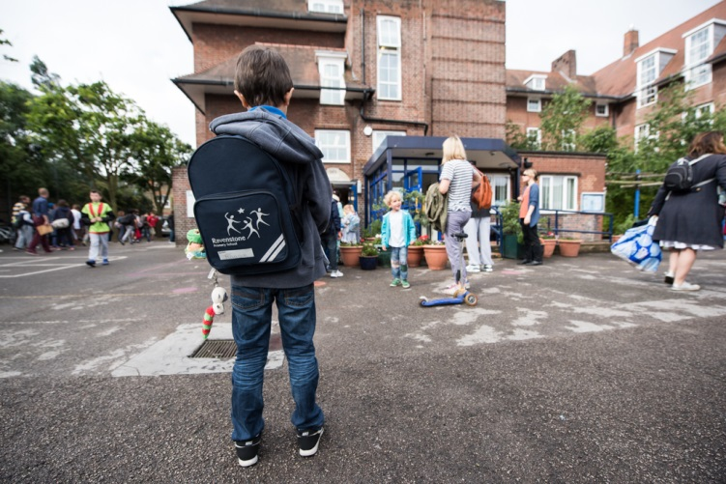


RAVENSTONE PRIMARY SCHOOL
Class Teacher – ASD hub
September 2019



Welcome and thank you for considering Ravenstone. I hope that this application pack gives you everything you need to consider working with us.
Ravenstone is a fantastic school. Every child that steps through the gates is welcomed into an aspirational, creative community that focuses on allowing children to flourish as individuals and reach their potential academically.
As Headteacher I passionately believe that we should allow our children to experience a wide range of creative enrichment opportunities and develop as confident, caring individuals who excel academically, and reach their full potential. It is this mixture that makes Ravenstone so special. We will not sacrifice any of these elements.
I believe that the success of a school is down to its teachers and I am proud to say that everything we focus on and do is to develop as professionals and deliver the best possible education for every child in our school. We constantly strive to improve and introduce initiatives that will inspire every pupil to achieve and become motivated individuals who can succeed in their futures.
We do everything we can to provide our pupils with the skill set to challenge the norm and become successful. Our curriculum is tailored towards the needs of the pupils and ranges from, high quality dance and music lessons, swimming in Year 4, 5 and 6 as well as a mastery approach to the core subjects and importantly a PSHE scheme of work that teaches our pupils to be safe, astute and adding to the world that they are growing up in.
This role is exciting because the successful applicant will join a well-established inclusion team who have already won awards for the provision they provide. As the Hive continues to expand we will continue to recruit the best possible staff to educate our children with EHCP’s with Autism being the primary focus.
Please do get in touch if I can help in any way possible.
Joe Croft
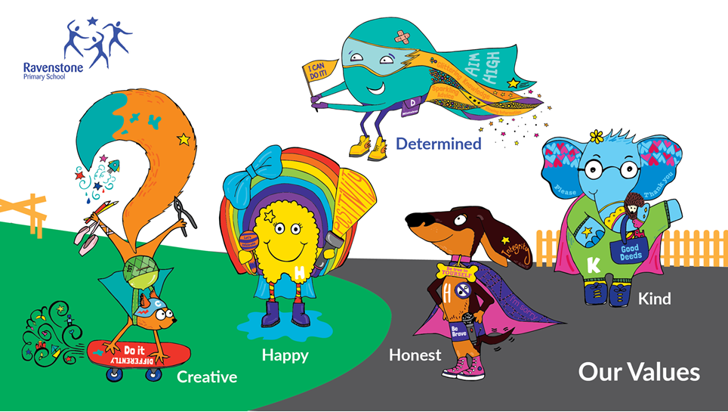

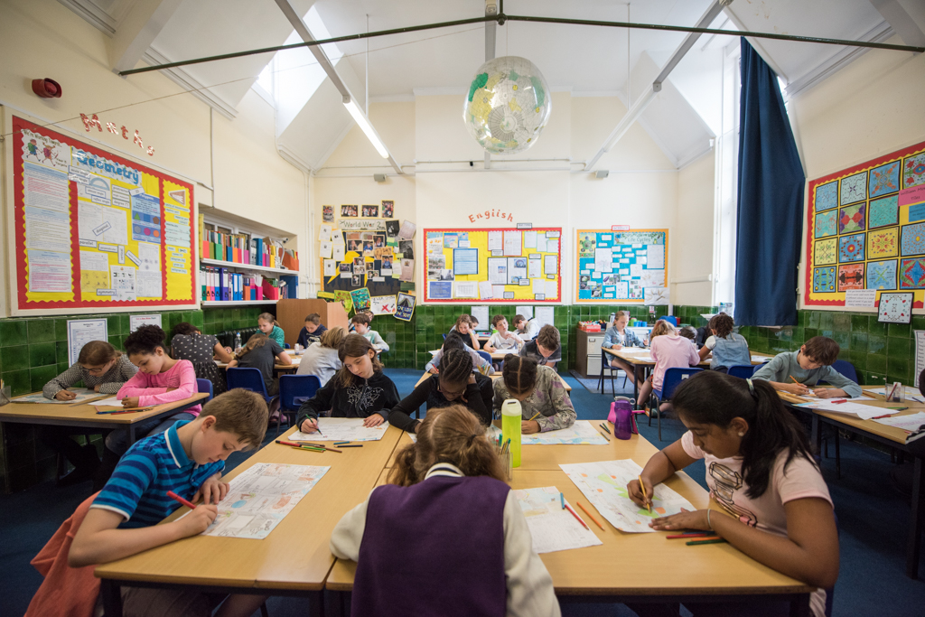
About Ravenstone
Ravenstone is a community primary school in Balham, funded by the London Borough of Wandsworth. The school has served the local community for the last 100 years. We are conveniently placed for public transport links – Balham main line train and tube station is 3 minutes away with easy access to all of London, Kent, Surrey and Sussex. We also have parking available onsite. The open space of Tooting Bec Common and the vibrant Balham centre are a few minutes from the school.
School organisation
380 children are currently on roll including full-time and part-time nursery children. These are arranged in 15 classes and the nursery. We are a two form entry school.
Autistic hub
The Hive is a brand new unit for children on the autism spectrum at Ravenstone School. We opened in November 2017. We will eventually cater for 16 pupils, from reception to year 6, but in this beginning phase we have 4 pupils, in reception and year 1 (2 in each year group). Pupils in The Hive have opportunities throughout the day to access mainstream education, with support from the specialised ASD trained staff. As we grow we will continue to recruit staff and at the start of September 2019 we will increase our staffing to 2 teachers, 2 teaching assistants and a TA.
Facilities:
- 2 classrooms set up according to TEACCH principles
- a sensory room
- a soft play room
- an outdoor learning garden
- therapy/quiet room for more individualised learning
- high staff-pupil ratio

What we provide:
- A highly differentiated curriculum to ensure the needs of all pupils are met and that all pupils progress to their fullest potential.
- An individualised approach to encourage independence and life skills.
- Fun and exciting learning opportunities, which help to remove the emotional barriers and to ensure a positive, safe and respectful environment for every pupil.
- Specialised teaching approaches using ASD specific strategies such as TEACCH, SCERTS, Intensive Interaction, Makaton and PECS.
- Inclusion opportunities in the mainstream school in relevant year groups.
- A commitment to working with parents through regular communication and workshops.
- A multidisciplinary approach to learning to ensure speech, language and communication needs are met, as well as motor skill development.
School focus
We are committed to the continuous improvement of every aspect of school life for children at Ravenstone. We seek to deliver an outstanding educational experience of the highest quality for children of diverse backgrounds and abilities. Enthusiasm, enjoyment, creativity, imagination and high expectations of both pupils and staff are at the centre of a wide variety of learning activities.
Our school vision is ‘Children reaching their potential in the heart of the community’ and our core values are Happy, Kind, Creative, Honest, Determined. We promote this in everything we do and we strive to allow our children to be confident individuals are understand themselves and will grow into well rounded adults who add to the world we live in.
As a school we focus on developing the adult as much as the child. We believe if every member of staff is the best they can possible be while constantly looking at ways to improve then this will provide our children with an outstanding environment to learn within.
Our ultimate aim is to become outstanding and continue to become a centre of excellence within the local community and beyond.
Community
We are proud to serve and be supported by our community. We offer a vibrant and rewarding environment with a committed team of hardworking staff, supportive governors and enthusiastic parents. The children are happy and keen to learn. We pride ourselves on the friendliness, confidence and character of our children.
The partnership between school and home is very important to us. We value parental involvement and have a thriving parents’ and carers’ association, Friends of Ravenstone, which organises social events and raises funds for the school which are used to enhance the children’s educational experience. Recently funds have been used to develop our music provision, the redevelopment of parts of the playground, the purchase of IT equipment and contributions to school trips and school journey.
We welcome volunteers from both the parent body and the local community to help in the school with reading, gardening, chess and newspaper clubs.
Everyone is encouraged to make a positive contribution to the wider community; on a local level, the school council recently organised a collection for a nearby foodbank. Looking further afield, for the last 14 years, we have had a partnership with a school in Yameriga, Ghana and Ravenstone children have been very active in supporting projects there.
Listening to pupils
The children elect representatives from each class to participate in the school council and discuss topics that are meaningful to the children. We value hearing pupils’ views and opinions and present them with regular opportunities in lessons and assemblies to voice these. Such information can offer ideas on how to improve their learning experience.
We have an established peer mentoring and mediation scheme so that the trained mentors can support their peers in the playground.
Curriculum enrichment/Ravenstone Entitlement
The Ravenstone entitlement is an offer to every child in the school. This offer includes at least one external trip, one inspirational internal visit and a curriculum themed day every term. We believe that every child deserved to learn in an engaging and purposeful learning environment that inspires them to become curious and ambitious.
Ravenstone celebrates each child’s participation and achievement in a wide range of activities including languages, food, art, sport, music and dance. We want all pupils to experience London’s rich diversity and we organise school trips as well as visits to the school by outside speakers.
Sport is one of the cornerstones of the school’s identity. We are fortunate to have a full time dedicated sports teacher and part time dance teacher and Ravenstone regularly excels in inter-school competitions. We have represented Wandsworth in athletics and swimming at the London Youth Games. Though competition is encouraged, children understand that sport is primarily undertaken for enjoyment and can be accessed by all, regardless of ability or experience.
Extra-curricular
We run a number of clubs before and after school and during lunchtimes: for example, choir, gardening, chess and newspaper club. We also have several externally-run clubs.

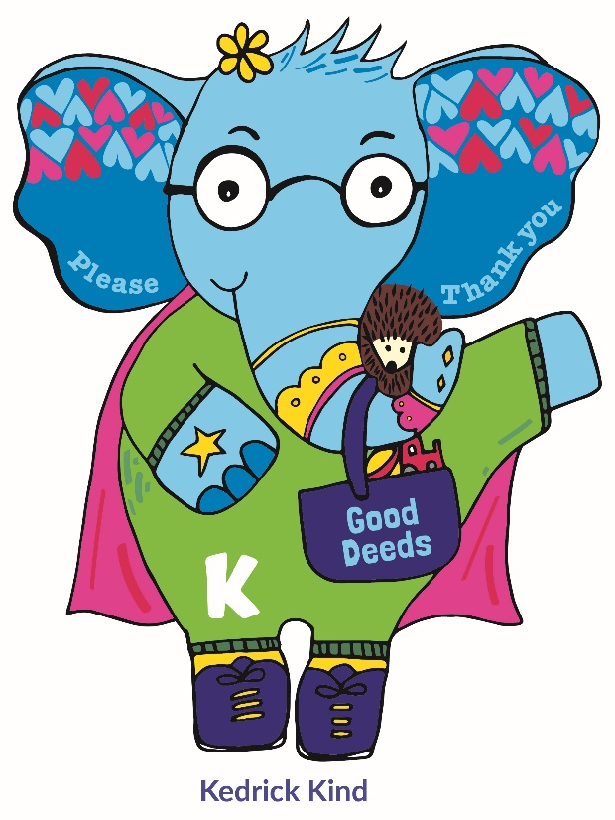
Working at Ravenstone
- A focus on work life balance and managing workload
- A culture of learning together
- Additional planning/leadership release at the end of every half term and term.
- A good school on the journey to outstanding
- A school that allows for teachers to flourish and allocates a large percentage of their budget to staff development
- An exceptionally well-resourced learning environment
- An Outstanding leadership team who think differently
- Excellent professional development and career progression opportunities
- A collaborative and caring school community which is culturally diverse and inclusive
- Wonderful pupils

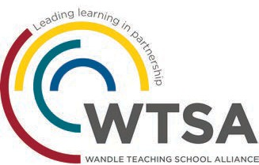

Wandle Teacher School Alliance

Ravenstone works as part of the Wandle Teacher School Alliance. The Alliance consists of a wide range of schools from different phases and specialisms and institutions who work together in a variety of ways to identify and tackle key issues within schools. We have a dedicated and enthusiastic staff in all phases and sectors. This depth and breadth of experience offers trainee teachers a unique opportunity to explore the many complex and exciting areas of teaching and learning. Whatever stage you are in your career the Teaching School and its partners offer a comprehensive package to support both career and professional development right through to Headship and Masters qualifications.
Maths Hub

The London South West Maths Hub aims to support schools in seven boroughs (Wandsworth, Merton, Sutton, Kingston, Richmond, Hillingdon and Hammersmith & Fulham) through a range of national and local projects each year. The core purpose of the Hub is to engineer a school based support network to develop Mastery style teaching at all levels of education.

As a school Ravenstone has embraced the support offered by the maths hub and our lead teacher is a mastery specialist and works with a range of other local schools.

Hillingdon and Hammersmith & Fulham) through a range of national and local projects each year. The core purpose of the Hub is to engineer
a school based support network to develop Mastery style teaching at all levels of education.

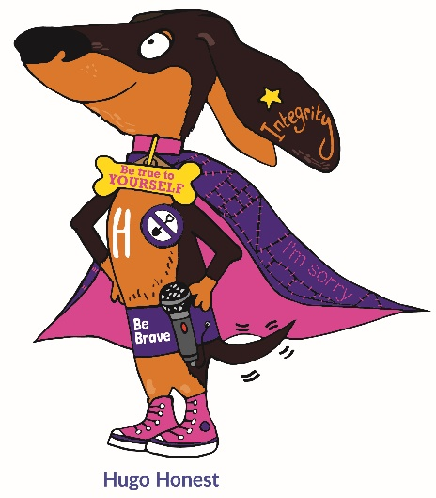

JOB DESCRIPTION
Position: Class Teacher – ASD hub
Grade: Dependant on applicant
Responsile to: Headteacher and Led by Head of ASD hub (The Hive)
Detail
1. The teacher will ensure that at all times they provide an effective, stimulating, well-organised classroom by:
- To care for and nurture the children within the school always

- To map out and develop a curriculum across the year group that stimulates pupil’s curiosity and overcomes barriers to learning

- To tailor interventions and support plans that allow for pupils to make good or better progress

- planning, preparing, assessing, evaluating and modifying teaching processes according to the National Curriculum, in line with the school's policies.

- ensuring assessment data is used to differentiate work and meeting all the varied needs of individual learners.

- selecting appropriate resources and making these accessible to learners.

- maintaining regular records of learner’s progress and achievement and reporting to parents as required.

- demonstrating high expectations for all pupils and setting targets which raise attainment

- marking and responding to pupil’s work, providing quality feedback, next steps and targets

- Engage with professional and career development opportunities so that constant reflection and up skilling is taking place

- To work alongside the leadership team in completing paperwork in support of EHCP applications and other forms of tracking and assessment

2. The teacher will contribute to the general development of the school by:
- working closely with teaching and support staff in the development and delivery of the curriculum, and the pastoral work of the school.

- attending relevant courses to support individual professional development and the school's needs.

- relating to, and communicating with, parents, and encouraging their active participation in their child’s education.

- participating in general, curricular and policy-making meetings.

- Offering to run extra curriculum clubs.

- Maintaining a positive attitude and embracing change

3. Personal responsibilities and other requirements
- developing links with governors, parents, LEA and neighboring schools

- undertake any professional duties reasonably delegated by the Head Teacher

- To be proactive in developing a reflective and positive approach towards self-improvement

- To be open to supporting colleagues within their own professional development

The teacher will ensure that the principles of The Equality Act and the Equal Opportunities policies of the Local Authority and the school are implemented at all times.

Safeguarding
Share the school’s commitment to safeguard, and promote the welfare of, the children in our care.
- to be fully aware of and understand the duties and responsibilities arising from London Child Protection Procedures, Working Together to Safeguard Children and Keeping Children Safe in Education in relation to child protection and safeguarding children and young people as this applies to the worker’s role within the organisation.

- to also be fully aware of the principles of safeguarding as they apply to vulnerable adults in relation to the staff member’s role.

- to ensure that the Designated Safeguarding Officers are made aware and kept fully informed of any concerns which the worker may have in relation to safeguarding and/or child protection.

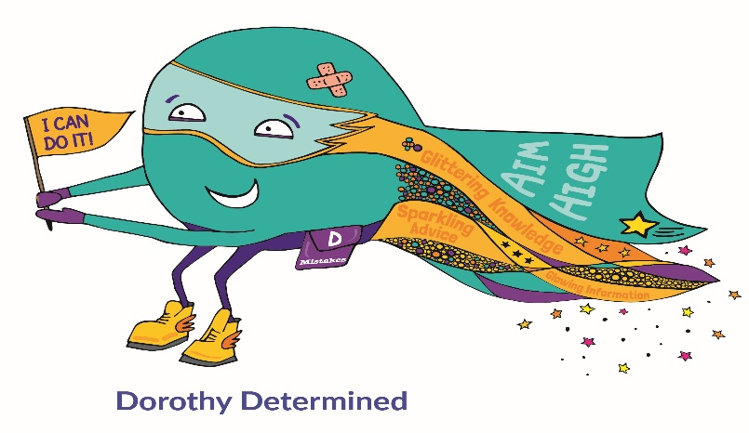

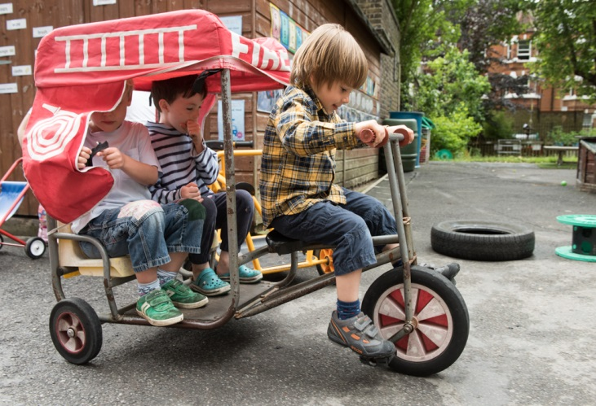

Person Specification

Qualifications Essential Desirable
Have achieved QTS status. – document/certificate required.  Evidence of ongoing relevant professional development. | Yes
Evidence of ongoing relevant professional development.  Evidence of ongoing relevant professional development. | yes
Experience – NQT’s welcome
Must have experience of teaching across the school | Yes
Experience of working in a primary school environment and respective phases | Yes
Professional knowledge and understanding
Must understand the expectations in the new Ofsted Framework | Yes
An understanding of curriculum and pedagogical issues relating to learning and teaching, | Yes
Classroom Practice rooted in up to date principles and guidance as well as knowledge of Equal opportunities and Inclusion. | Yes
Knowledge of effective strategies to include, and meet the needs of, all pupils within English teaching, in particular underachieving groups of pupils, pupils  with EAL and SEND. | Yes
To have a good understanding of the needs of pupils who have recently arrived in the country and/or pupils who are vulnerable to high levels of mobility and be able to use this knowledge to inform policy and practice | Yes
Have a good understanding of positive effective strategies for behaviour management | Yes
To understand the principle of Racial Equality and Equality of Opportunity and how these may inform whole school policy | Yes
Evidence of knowledge and use of a range of assessment strategies to track and support pupil progress. | Yes
To understand what is involved in the role of Child Protection Officer, including having a good understanding of up to date policy and practice | Yes

Professional skills and abilities Essential Desirable
Must be able to plan lessons effectively for all the pupils  in a class, setting clear learning intentions and differentiated tasks | Yes
Must have a basic understanding of data and tracking of pupils progress | Yes
Use of a range of teaching styles to motivate, engage and inspire all learners. | Yes
Ability to communicate well and work in partnership with parents and carers. | Yes
Personal qualities
To relish challenge | Yes
Must be willing to and passionate for the profession | Yes
To have a flexible approach to work who enjoys being a good team member | Yes
To have high aspirations for their future career | Yes
Must have good communication skills both orally and in writing | Yes
Must be able to manage own workload effectively and respond swiftly to tight deadlines | Yes
Good interpersonal skills, with the ability to enthuse and motivate others and develop effective partnerships | Yes
Willingness to share expertise, skills and knowledge | Yes
Willingness to engage with whole school INSET | Yes
To practise equal opportunities in all aspects of the role and around the workplace in line with policy | Yes
To maintain a personal commitment to professional development  linked to the competencies necessary to deliver the requirements of this post | Yes
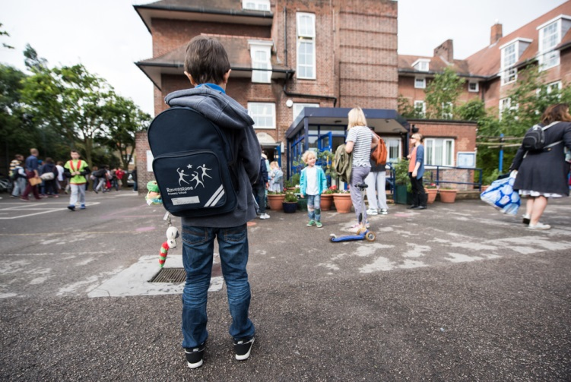
RAVENSTONE PRIMARY SCHOOL
Class Teacher – ASD hub
September 2019

Contact us;
Telephone: 0208 673 0594020 7622 1619
Email:
Info@ravenstone.wandsworth.sch.uk

Are you looking towards teaching in an outstanding educational environment and would you like the opportunity to be part of a dynamic and very committed team?
If so you should apply to work at Ravenstone Primary school where you will benefit from:

- Excellent professional development and career progression opportunities.
- Working with highly aspirational and caring group of professionals who care deeply the children.
- An exceptionally well resourced learning environment.
- A caring and supportive whole school community which is culturally diverse and inclusive.
- The chance to work within the first primary school in Wandsworth to achieve the ASD and inclusion award.

Visits are welcome and actively encouraged as you will be able to gain an overview of the school and the school community. Please phone 020 8673 0594 to arrange a mutually convenient time.
To apply please download an application and details from this web page or from the Wandsworth Council website https://jobs.wandsworth.gov.uk/

Completed applications should be returned to the school by email on: info@ravenstone.wandsworth.sch.uk

School tours: (contact us to arrange)
Closing Date: 3rd May - Interviews: 9th May
We are committed to safeguarding and promoting the welfare of children, young people and vulnerable adults and expect all staff and volunteers to share this commitment. This post is subject to an enhanced DBS check. CVs are not accepted.

